Additional Materials: Convolutional Neural Networks

# Lesson 1: Additional Materials: CNN

## Applications of CNNs

<https://www.youtube.com/watch?time_continue=0&v=HrYNL_1SV2Y&feature=emb_logo>

### Optional Resources

* Read about the [WaveNet](https://deepmind.com/blog/wavenet-generative-model-raw-audio/" \t "_blank) model.
  + Why train an A.I. to talk, when you can train it to sing ;)? In April 2017, researchers used a variant of the WaveNet model to generate songs. The original paper and demo can be found [here](http://www.creativeai.net/posts/W2C3baXvf2yJSLbY6/a-neural-parametric-singing-synthesizer).
* Learn about CNNs [for text classification](http://www.wildml.com/2015/12/implementing-a-cnn-for-text-classification-in-tensorflow/).
  + You might like to sign up for the author's [Deep Learning Newsletter](https://www.getrevue.co/profile/wildml)!
* Read about Facebook's [novel CNN approach](https://code.facebook.com/posts/1978007565818999/a-novel-approach-to-neural-machine-translation/) for language translation that achieves state-of-the-art accuracy at nine times the speed of RNN models.
* Play [Atari games](https://deepmind.com/research/dqn/) with a CNN and reinforcement learning. You can [download](https://sites.google.com/a/deepmind.com/dqn/) the code that comes with this paper.
  + If you would like to play around with some beginner code (for deep reinforcement learning), you're encouraged to check out Andrej Karpathy's [post](http://karpathy.github.io/2016/05/31/rl/).
* Play [pictionary](https://quickdraw.withgoogle.com/" \t "_blank) with a CNN!
  + Also check out all of the other cool implementations on the [A.I. Experiments](https://aiexperiments.withgoogle.com/) website. Be sure not to miss [AutoDraw](https://www.autodraw.com/" \t "_blank)!
* Read more about [AlphaGo](https://deepmind.com/research/alphago/).
  + Check out [this article](https://www.technologyreview.com/s/604273/finding-solace-in-defeat-by-artificial-intelligence/?set=604287), which asks the question: If mastering Go “requires human intuition,” what is it like to have a piece of one’s humanity challenged?
* Check out these really cool videos with drones that are powered by CNNs.
  + Here's an interview with a startup - [Intelligent Flying Machines (IFM)](https://www.youtube.com/watch?v=AMDiR61f86Y).
  + Outdoor autonomous navigation is typically accomplished through the use of the [global positioning system (GPS)](http://www.droneomega.com/gps-drone-navigation-works/), but here's a demo with a CNN-powered [autonomous drone](https://www.youtube.com/watch?v=wSFYOw4VIYY).
* If you're excited about using CNNs in self-driving cars, you're encouraged to check out:
  + our [Self-Driving Car Engineer Nanodegree](https://www.udacity.com/course/self-driving-car-engineer-nanodegree--nd013), where we classify signs in the [German Traffic Sign](http://benchmark.ini.rub.de/?section=gtsrb&subsection=dataset) dataset in [this project](https://github.com/udacity/CarND-Traffic-Sign-Classifier-Project).
  + our [Machine Learning Engineer Nanodegree](https://www.udacity.com/course/machine-learning-engineer-nanodegree--nd009), where we classify house numbers from the [Street View House Numbers](http://ufldl.stanford.edu/housenumbers/) dataset in [this project](https://github.com/udacity/machine-learning/tree/master/projects/digit_recognition).
  + this [series of blog posts](https://pythonprogramming.net/game-frames-open-cv-python-plays-gta-v/) that details how to train a CNN in Python to produce a self-driving A.I. to play Grand Theft Auto V.
* Check out some additional applications not mentioned in the video.
  + Some of the world's most famous paintings have been [turned into 3D](http://www.businessinsider.com/3d-printed-works-of-art-for-the-blind-2016-1) for the visually impaired. Although the article does not mention how this was done, we note that it is possible to use a CNN to [predict depth](https://www.cs.nyu.edu/~deigen/depth/) from a single image.
  + Check out [this research](https://research.googleblog.com/2017/03/assisting-pathologists-in-detecting.html) that uses CNNs to localize breast cancer.
  + CNNs are used to [save endangered species](https://blogs.nvidia.com/blog/2016/11/04/saving-endangered-species/?adbsc=social_20170303_70517416)!
  + An app called [FaceApp](http://www.digitaltrends.com/photography/faceapp-neural-net-image-editing/" \t "_blank) uses a CNN to make you smile in a picture or change genders.

## Lesson Outline

Hi, I'm [Cezanne Camacho](https://twitter.com/cezannecam), I'll be teaching this lesson in tandem with Alexis, and later on, show you how to implement CNNs in PyTorchand use them in a variety of ways.

<https://www.youtube.com/watch?time_continue=0&v=77LzWE1qQrc&feature=emb_logo>

### What is a feature?

I’ve found that a helpful way to think about what a **feature** is, is to think about what we are visually drawn to when we first see an object and when we identify different objects. For example, what do we look at to distinguish a cat and a dog? The shape of the eyes, the size, and how they move are just a couple of examples of visual features.

As another example, say we see a person walking toward us and we want to see if it’s someone we know; we may look at their face, and even further their general shape, eyes (and even color of their eyes). The distinct shape of a person and their eye color a great examples of distinguishing features!

Next, we’ll see that features like these can be measured, and represented as numerical data, by a machine.

## How Computers Interpret Images

<https://www.youtube.com/watch?time_continue=0&v=mEPfoM68Fx4&feature=emb_logo>

### Normalizing image inputs

Data normalization is an important pre-processing step. It ensures that each input (each pixel value, in this case) comes from a standard distribution. That is, the range of pixel values in one input image are the same as the range in another image. This standardization makes our model train and reach a minimum error, faster!

Data normalization is typically done by subtracting the mean (the average of all pixel values) from each pixel, and then dividing the result by the standard deviation of all the pixel values. Sometimes you'll see an approximation here, where we use a mean and standard deviation of 0.5 to center the pixel values. [Read more about the Normalize transformation in PyTorch.](https://pytorch.org/docs/stable/torchvision/transforms.html#transforms-on-torch-tensor)

The distribution of such data should resemble a [Gaussian function](http://mathworld.wolfram.com/GaussianFunction.html) centered at zero. For image inputs we need the pixel numbers to be positive, so we often choose to scale the data in a normalized range [0,1].

## MLP Structure & Class Score

<https://www.youtube.com/watch?time_continue=0&v=fP0Odiai8sk&feature=emb_logo>

## Loss & Optimization

<https://www.youtube.com/watch?time_continue=0&v=BmPDtSXv18w&feature=emb_logo>

## Defining a Network in PyTorch

<https://www.youtube.com/watch?time_continue=1&v=9gvaQvyfLfY&feature=emb_logo>

### ReLU Activation Function

The purpose of an activation function is to scale the outputs of a layer so that they are a consistent, small value. Much like normalizing input values, this step ensures that our model trains efficiently!

A ReLU activation function stands for "Rectified Linear Unit" and is one of the most commonly used activation functions for hidden layers. It is an activation function, simply defined as the **positive** part of the input, x. So, for an input image with any negative pixel values, this would turn all those values to 0, black. You may hear this referred to as "clipping" the values to zero; meaning that is the lower bound.

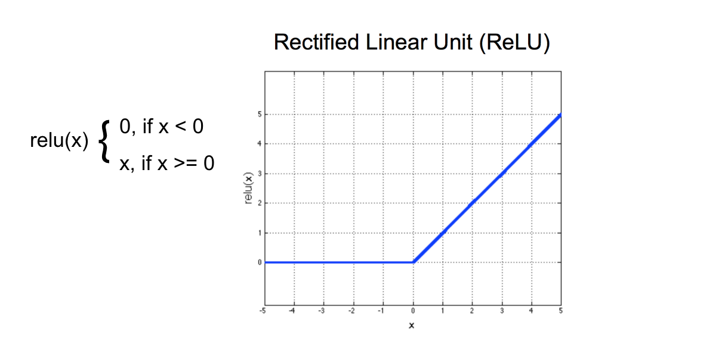

ReLU function

## Training the Network

<https://www.youtube.com/watch?v=904bfqibcCw&feature=emb_logo>

### Cross-Entropy Loss

In the [PyTorch documentation](https://pytorch.org/docs/stable/nn.html" \l "crossentropyloss" \t "_blank), you can see that the cross entropy loss function actually involves two steps:

* It first applies a softmax function to any output is sees
* Then applies [NLLLoss](https://pytorch.org/docs/stable/nn.html" \l "nllloss" \t "_blank); negative log likelihood loss

Then it returns the average loss over a batch of data. Since it applies a softmax function, we do not have to specify that in the forward function of our model definition, but we could do this another way.

#### Another approach

We could separate the softmax and NLLLoss steps.

* In the forward function of our model, we would explicitly apply a softmax activation function to the output, x.

**...**

**...**

*# a softmax layer to convert 10 outputs into a distribution of class probabilities*

x = F.log\_softmax(x, dim=1)

**return** x

* Then, when defining our loss criterion, we would apply NLLLoss

*# cross entropy loss combines softmax and nn.NLLLoss() in one single class*

*# here, we've separated them*

criterion = nn.NLLLoss()

This separates the usual criterion = nn.CrossEntropy() into two steps: softmax and NLLLoss, and is a useful approach should you want the output of a model to be class probabilities rather than class scores.

## Notebook: MLP Classification

Now, you're ready to define and train an MLP in PyTorch. As you follow along this lesson, you are encouraged to open the referenced Jupyter notebooks. We will present a solution to you, but please try creating your own deep learning models! Much of the value in this experience will come from experimenting with the code, in your own way.

To open this notebook, you have two options:

* *Go to the next page in the classroom (recommended).*
* *Clone the repo from*[*Github*](https://github.com/udacity/deep-learning-v2-pytorch)*and open the notebook****mnist\_mlp\_exercise.ipynb****in the****convolutional-neural-networks > mnist-mlp****folder. You can either download the repository with git clone https://github.com/udacity/deep-learning-v2-pytorch.git, or download it as an archive file from*[*this link*](https://github.com/udacity/deep-learning-v2-pytorch/archive/master.zip)*.*

### Instructions

* Define an MLP model for classifying MNIST images
* Train it for some number of epochs and test your model to see how well it generalizes and measure its accuracy.

This is a self-assessed lab. If you need any help or want to check your answers, feel free to check out the solutions notebook in the same folder, or by clicking [here](https://github.com/udacity/deep-learning-v2-pytorch/blob/master/convolutional-neural-networks/mnist-mlp/mnist_mlp_solution.ipynb).

## One Solution

<https://www.youtube.com/watch?time_continue=0&v=7q37WPjQhDA&feature=emb_logo>

#### model.eval()

There is an omission in the above code: including model.eval() !

model.eval() will set all the layers in your model to evaluation mode. This affects layers like dropout layers that turn "off" nodes during training with some probability, but should allow every node to be "on" for evaluation. So, you should set your model to evaluation mode **before testing or validating your model** and set it to model.train() (training mode) only during the training loop.

This is reflected in the previous notebook code and in our **[Github repository](https://github.com/udacity/deep-learning-v2-pytorch/tree/master/convolutional-neural-networks/mnist-mlp" \t "_blank)**.

### Optional Resources

* Check out the [**first research paper**](https://www.cs.toronto.edu/~hinton/absps/JMLRdropout.pdf) to propose dropout as a technique for overfitting.
* If you'd like more information on activation functions, check out this [**website**](http://cs231n.github.io/neural-networks-1/#actfun).

## ModelValidation

<https://www.youtube.com/watch?v=b5934VsV3SA&feature=emb_logo>

### Validation Loss

<https://www.youtube.com/watch?time_continue=0&v=uGPP_-pbBsc&feature=emb_logo>

### Validation Code

You can take a look at the complete validation code in the previous notebook directory, or, directly in the **[Github repository](https://github.com/udacity/deep-learning-v2-pytorch/blob/master/convolutional-neural-networks/mnist-mlp/mnist_mlp_solution_with_validation.ipynb" \t "_blank)**.

### Validation Set: Takeaways

We create a validation set to

1. Measure how well a model generalizes, during training
2. Tell us when to stop training a model; when the validation loss stops decreasing (and especially when the validation loss starts increasing and the training loss is still decreasing)

## ImageClassification

<https://www.youtube.com/watch?time_continue=0&v=UHFBnitKraA&feature=emb_logo>

## MLP vs CNN

<https://www.youtube.com/watch?v=Q7CR3cCOtJQ&feature=emb_logo>

## Local Connectivity

<https://www.youtube.com/watch?v=z9wiDg0w-Dc&feature=emb_logo>

## Filters and the Convolution Layers

<https://www.youtube.com/watch?v=x_dhnhUzFNo&feature=emb_logo>

## Filters & Edges

<https://www.youtube.com/watch?time_continue=0&v=hfqNqcEU6uI&feature=emb_logo>

## Frequency in Images

We have an intuition of what frequency means when it comes to sound. High-frequency is a high pitched noise, like a bird chirp or violin. And low frequency sounds are low pitch, like a deep voice or a bass drum. For sound, frequency actually refers to how fast a sound wave is oscillating; oscillations are usually measured in cycles/s ([**Hz**](https://en.wikipedia.org/wiki/Hertz)), and high pitches and made by high-frequency waves. Examples of low and high-frequency sound waves are pictured below. On the y-axis is amplitude, which is a measure of sound pressure that corresponds to the perceived loudness of a sound, and on the x-axis is time.

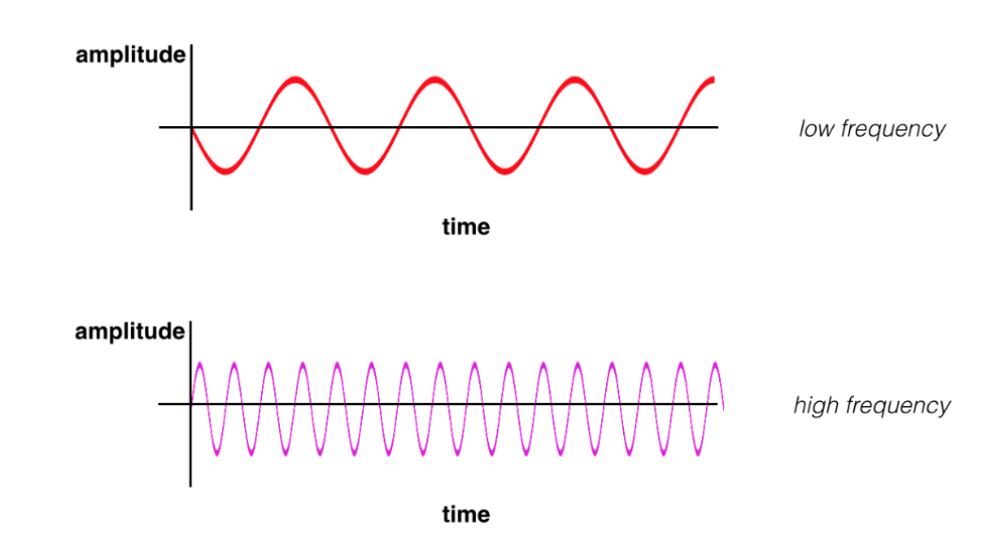

(Top image) a low frequency sound wave (bottom) a high frequency sound wave.

### High and low frequency

Similarly, frequency in images is a **rate of change**. But, what does it means for an image to change? Well, images change in space, and a high frequency image is one where the intensity changes a lot. And the level of brightness changes quickly from one pixel to the next. A low frequency image may be one that is relatively uniform in brightness or changes very slowly. This is easiest to see in an example.

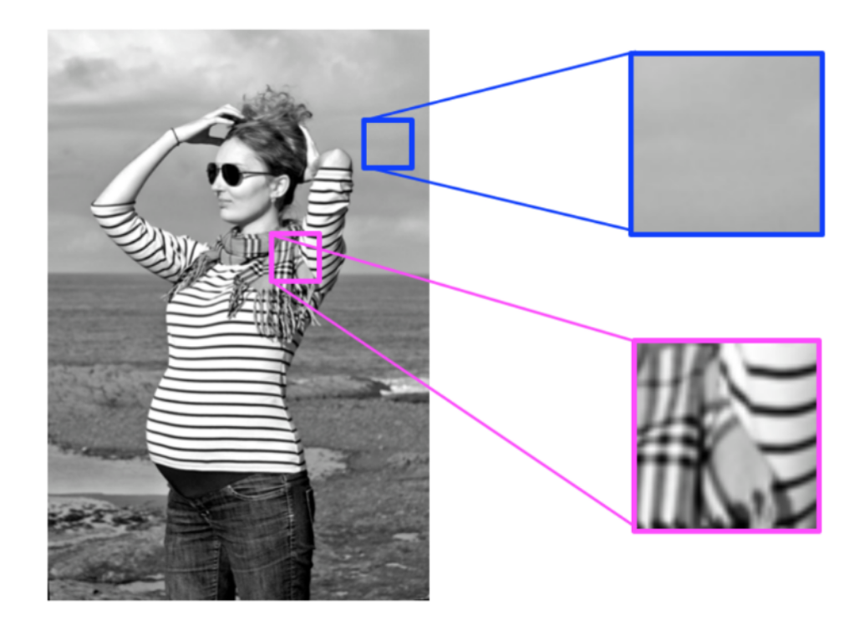

High and low frequency image patterns.

Most images have both high-frequency and low-frequency components. In the image above, on the scarf and striped shirt, we have a high-frequency image pattern; this part changes very rapidly from one brightness to another. Higher up in this same image, we see parts of the sky and background that change very gradually, which is considered a smooth, low-frequency pattern.

**High-frequency components also correspond to the edges of objects in images**, which can help us classify those objects.

## High-pass Filters

<https://www.youtube.com/watch?v=OpcFn_H2V-Q&feature=emb_logo>

### Edge Handling

Kernel convolution relies on centering a pixel and looking at it's surrounding neighbors. So, what do you do if there are no surrounding pixels like on an image corner or edge? Well, there are a number of ways to process the edges, which are listed below. It’s most common to use padding, cropping, or extension. In extension, the border pixels of an image are copied and extended far enough to result in a filtered image of the same size as the original image.

**Extend** The nearest border pixels are conceptually extended as far as necessary to provide values for the convolution. Corner pixels are extended in 90° wedges. Other edge pixels are extended in lines.

**Padding** The image is padded with a border of 0's, black pixels.

**Crop** Any pixel in the output image which would require values from beyond the edge is skipped. This method can result in the output image being slightly smaller, with the edges having been cropped.

## OpenCV

Before we jump into coding our own convolutional kernels/filters, I'll introduce you to a new library that will be useful to use when dealing with computer vision tasks, such as image classification: OpenCV!



OpenCV logo

OpenCV is a **computer vision and machine learning software library** that includes many common image analysis algorithms that will help us build custom, intelligent computer vision applications. To start with, this includes tools that help us process images and select areas of interest! The library is widely used in academic and industrial applications; from [**their site**](http://opencv.org/about.html), OpenCV includes an impressive list of users: “Along with well-established companies like Google, Yahoo, Microsoft, Intel, IBM, Sony, Honda, Toyota that employ the library, there are many startups such as Applied Minds, VideoSurf, and Zeitera, that make extensive use of OpenCV.”

So, note, how we import cv2 in the next notebook and use it to create and apply image filters!

## Notebook: Custom Filters

The next notebook is called custom\_filters.ipynb.

To open the notebook, you have two options:

* Go to the next page in the classroom (recommended).
* Clone the repo from [**Github**](https://github.com/udacity/deep-learning-v2-pytorch) and open the notebook **custom\_filters.ipynb** in the **convolutional-neural-networks > conv-visualization** folder. You can either download the repository with git clone https://github.com/udacity/deep-learning-v2-pytorch.git, or download it as an archive file from [**this link**](https://github.com/udacity/deep-learning-v2-pytorch/archive/master.zip).

### Instructions

* Define your own convolutional filters and apply them to an image of a road
* See if you can define filters that detect horizontal or vertical edges

This notebook is meant to be a playground where you can try out different filter sizes and weights and see the resulting, filtered output image!

## Convolutional Layer

### The Importance of Filters

What you've just learned about different types of filters will be really important as you progress through this course, especially when you get to Convolutional Neural Networks (CNNs). CNNs are a kind of deep learning model that can learn to do things like image classification and object recognition. They keep track of spatial information and learn to extract features like the edges of objects in something called a **convolutional layer**. Below you'll see an simple CNN structure, made of multiple layers, below, including this "convolutional layer".

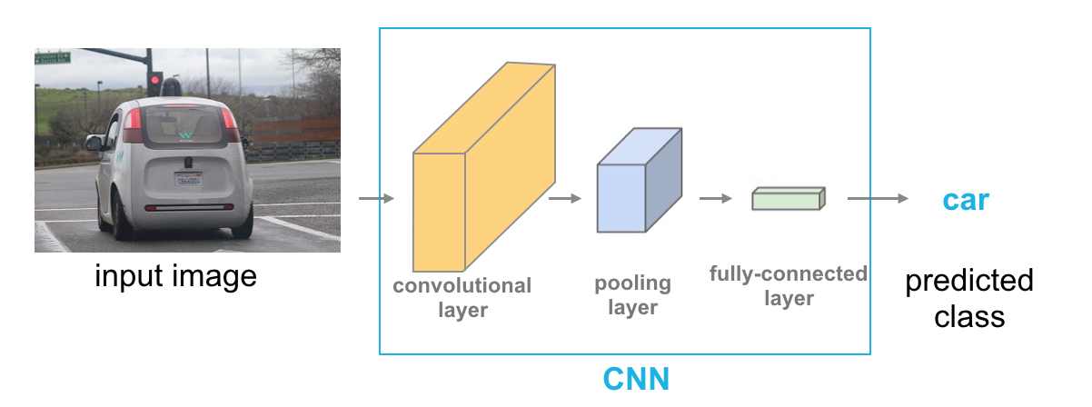

Layers in a CNN.

### Convolutional Layer

The convolutional layer is produced by applying a series of many different image filters, also known as convolutional kernels, to an input image.

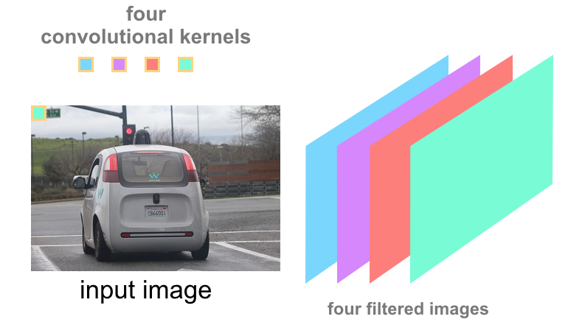

4 kernels = 4 filtered images.

In the example shown, 4 different filters produce 4 differently filtered output images. When we stack these images, we form a complete convolutional layer with a depth of 4!

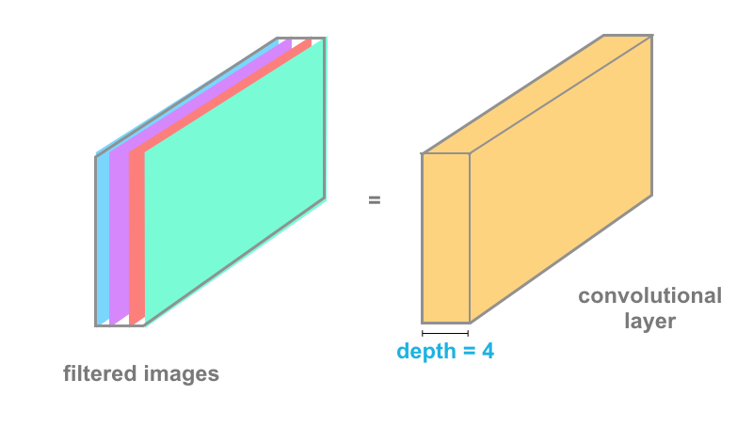

A convolutional layer.

### Learning

In the code you've been working with, you've been setting the values of filter weights explicitly, but neural networks will actually learn the best filter weights as they train on a set of image data. You'll learn all about this type of neural network later in this section, but know that high-pass and low-pass filters are what define the behavior of a network like this, and you know how to code those from scratch!

In practice, you'll also find that many neural networks learn to detect the edges of images because the edges of object contain valuable information about the shape of an object.

## Convolutional Layers (Part 2)

<https://www.youtube.com/watch?time_continue=1&v=RnM1D-XI--8&feature=emb_logo>

The Jupyter notebook described in the video can be accessed from the deep-learning-v2-pytorch GitHub respository linked [**here**](https://github.com/udacity/deep-learning-v2-pytorch/tree/master/convolutional-neural-networks). Navigate to the **conv-visualization/** folder and open **conv\_visualization.ipynb**.

### Optional Resource

* Check out [**this website**](http://setosa.io/ev/image-kernels/), which allows you to create your own filter. You can then use your webcam as input to a convolutional layer and visualize the corresponding activation map!

## Stride and Padding

<https://www.youtube.com/watch?time_continue=0&v=GmStpNi8jBI&feature=emb_logo>

## Pooling Layers

<https://www.youtube.com/watch?v=_Ok5xZwOtrk&feature=emb_logo>

### Other kinds of pooling

Alexis mentioned one other type of pooling, and it is worth noting that some architectures choose to use [**average pooling**](https://pytorch.org/docs/stable/nn.html#avgpool2d), which chooses to average pixel values in a given window size. So in a 2x2 window, this operation will see 4 pixel values, and return a single, average of those four values, as output!

This kind of pooling is typically not used for image classification problems because maxpooling is better at noticing the most important details about edges and other features in an image, but you may see this used in applications for which smoothing an image is preferable.

## Notebook: Layer Visualizations

The next notebooks are about visualizing the output of convolutional and pooling layers.

To open the notebook, you have two options:

* Go to the next page in the classroom (recommended).
* Clone the repo from [**Github**](https://github.com/udacity/deep-learning-v2-pytorch) and open the notebook **conv\_visualization.ipynb** & **maxpooling\_visualization.ipynb** in the **convolutional-neural-networks > conv-visualization** folder. You can either download the repository with git clone https://github.com/udacity/deep-learning-v2-pytorch.git, or download it as an archive file from [**this link**](https://github.com/udacity/deep-learning-v2-pytorch/archive/master.zip).

### Instructions

This notebook is meant to give you a chance to explore the effect of convolutional layers, activations, and pooling layers!

## Capsule Networks

### Alternatives to Pooling

It's important to note that pooling operations do throw away some image information. That is, they discard pixel information in order to get a smaller, feature-level representation of an image. This works quite well in tasks like image classification, but it can cause some issues.

Consider the case of facial recognition. When you think of how you identify a face, you might think about noticing features; two eyes, a nose, and a mouth, for example. And those pieces, together, form a complete face! A typical CNN that is trained to do facial recognition, should also learn to identify these features. Only, by distilling an image into a feature-level representation, you might get a weird result:

* Given an image of a face that has been photoshopped to include three eyes or a nose placed above the eyes, a feature-level representation will identify these features and still recognize a face! Even though that face is fake/contains too many features in an atypical orientation.

So, there has been research into classification methods that do not discard spatial information (as in the pooling layers), and instead learn to spatial relationships between parts (like between eyes, nose, and mouth).

One such method, for learning spatial relationships between parts, is the **capsule network**.

### Capsule Networks

Capsule Networks provide a way to detect parts of objects in an image and represent spatial relationships between those parts. This means that capsule networks are able to recognize the same object, like a face, in a variety of different poses and with the typical number of features (eyes, nose , mouth) even if they have not seen that pose in training data.

Capsule networks are made of parent and child nodes that build up a complete picture of an object.

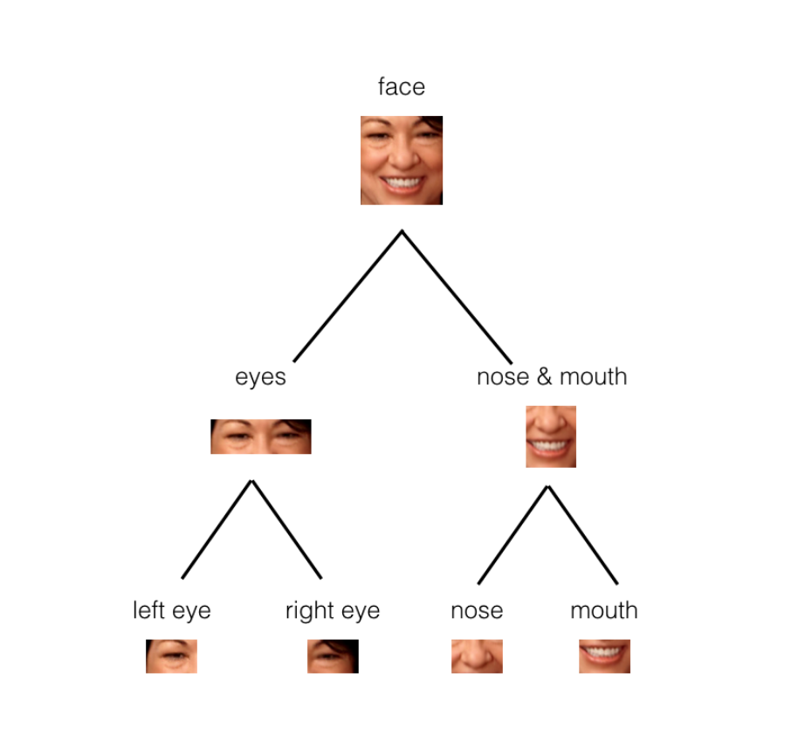

In the example above, you can see how the parts of a face (eyes, nose, mouth, etc.) might be recognized in leaf nodes and then combined to form a more complete face part in parent nodes.

#### What are Capsules?

Capsules are essentially a collection of nodes, each of which contains information about a specific part; part properties like width, orientation, color, and so on. The important thing to note is that each capsule **outputs a vector** with some magnitude and orientation.

* Magnitude (m) = the probability that a part exists; a value between 0 and 1.
* Orientation (theta) = the state of the part properties.

These output vectors allow us to do some powerful routing math to build up a parse tree that recognizes whole objects as comprised of several, smaller parts!

The magnitude is a special part property that should stay very high even when an object is in a different orientation, as shown below.

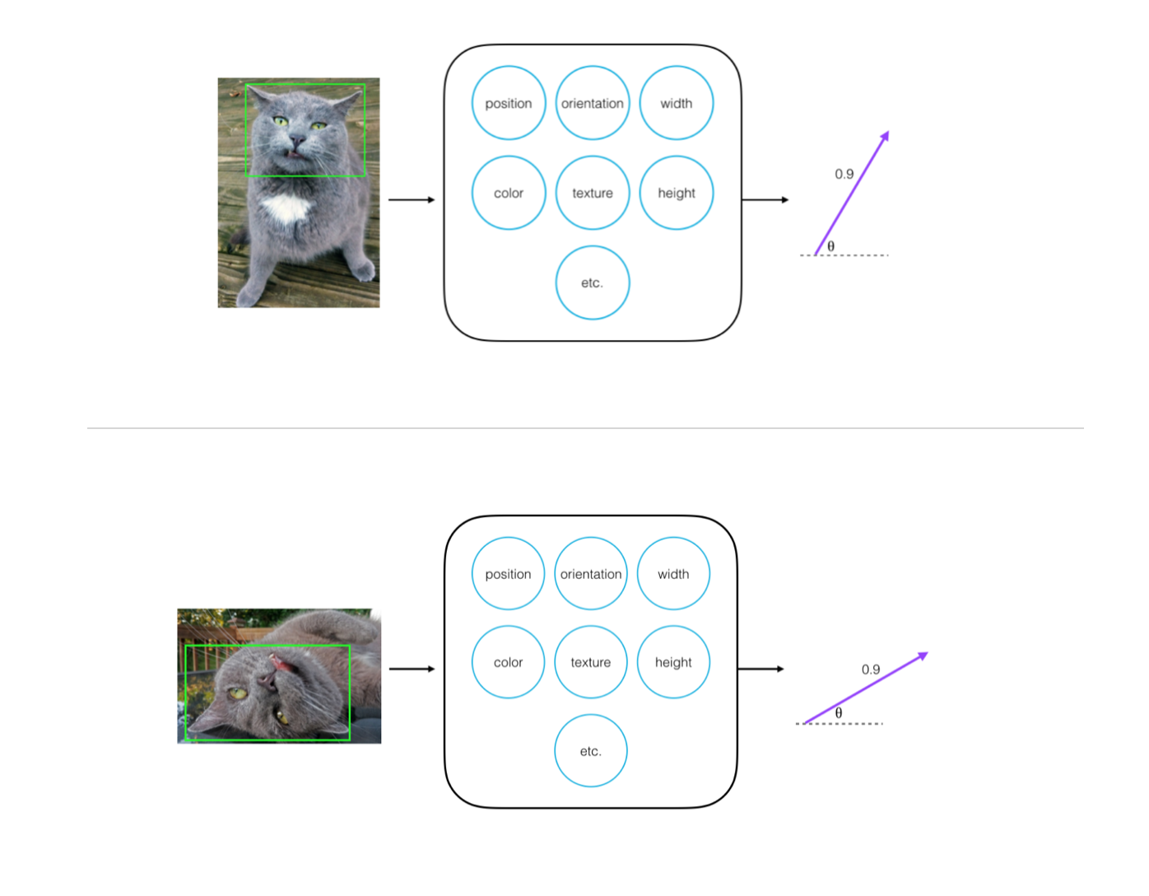

Cat face, recognized in a multiple orientations, co: [**this blog post**](https://cezannec.github.io/Capsule_Networks/).

#### Resources

* You can learn more about [**capsules, in this blog post**](https://cezannec.github.io/Capsule_Networks/).
* And experiment with an implementation of a capsule network in PyTorch, [**at this github repo**](https://github.com/cezannec/capsule_net_pytorch).

### Supporting Materials

[**Dynamic routing between capsules, hinton et al**](https://video.udacity-data.com/topher/2018/November/5bfdca4f_dynamic-routing/dynamic-routing.pdf)

## Increasing Depth

<https://www.youtube.com/watch?time_continue=0&v=YKif1KNpWeE&feature=emb_logo>

## CNNs for Image Classification

<https://www.youtube.com/watch?v=smaw5GqRaoY&feature=emb_logo>

### Padding

Padding is just adding a border of pixels around an image. In PyTorch, you specify the size of this border.

Why do we need padding?

When we create a convolutional layer, we move a square filter around an image, using a center-pixel as an anchor. So, this kernel cannot perfectly overlay the edges/corners of images. The nice feature of padding is that it will allow us to control the spatial size of the output volumes (most commonly as we’ll see soon we will use it to exactly preserve the spatial size of the input volume so the input and output width and height are the same).

The most common methods of padding are padding an image with all 0-pixels (zero padding) or padding them with the nearest pixel value. You can read more about calculating the amount of padding, given a kernel\_size, [**here**](http://cs231n.github.io/convolutional-networks/#conv).

### QUESTION 1 OF 2

How might you define a **[Maxpooling layer](https://pytorch.org/docs/stable/nn.html" \l "maxpool2d" \t "_blank)**, such that it down-samples an input by a factor of **4**? (A checkbox indicates that you should select **ALL** answers that apply.)

* 

nn.MaxPool2d(2, 4)

* 

nn.MaxPool2d(2, 2)

* 

nn.MaxPool2d(4, 4)

* 

nn.MaxPool2d(4, 2)

SUBMIT

### QUESTION 2 OF 2

If you want to define a convolutional layer that is the same x-y size as an input array, what **padding** should you have for a kernel\_size of 7? (You may assume that other parameters are left as their default values.)

* 

padding=0

* 

padding=1

* 

padding=2

* 

padding=3

* 

padding=7

SUBMIT

### PyTorch Layer Documentation

#### Convolutional Layers

We typically define a convolutional layer in PyTorch using nn.Conv2d, with the following parameters, specified:

nn.Conv2d(in\_channels, out\_channels, kernel\_size, stride=1, padding=0)

* in\_channels refers to the depth of an input. For a grayscale image, this depth = 1
* out\_channels refers to the desired depth of the output, or the number of filtered images you want to get as output
* kernel\_size is the size of your convolutional kernel (most commonly 3 for a 3x3 kernel)
* stride and padding have default values, but should be set depending on how large you want your output to be in the spatial dimensions x, y

[**Read more about Conv2d in the documentation**](https://pytorch.org/docs/stable/nn.html#conv2d).

#### Pooling Layers

Maxpooling layers commonly come after convolutional layers to shrink the x-y dimensions of an input, read more about pooling layers in PyTorch, [**here**](https://pytorch.org/docs/stable/nn.html#maxpool2d).

## Convolutional Layers in PyTorch

To create a convolutional layer in PyTorch, you must first import the necessary module:

**import** torch.nn **as** nn

Then, there is a two part process to defining a convolutional layer and defining the feedforward behavior of a model (how an input moves through the layers of a network). First, you must define a Model class and fill in two functions.

**init**

You can define a convolutional layer in the \_\_init\_\_ function of by using the following format:

self.conv1 = nn.Conv2d(in\_channels, out\_channels, kernel\_size, stride=1, padding=0)

**forward**

Then, you refer to that layer in the forward function! Here, I am passing in an input image x and applying a ReLU function to the output of this layer.

x = F.relu(**self**.conv1(x))

### Arguments

You must pass the following arguments:

* in\_channels - The number of inputs (in depth), 3 for an RGB image, for example.
* out\_channels - The number of output channels, i.e. the number of filtered "images" a convolutional layer is made of or the number of unique, convolutional kernels that will be applied to an input.
* kernel\_size - Number specifying both the height and width of the (square) convolutional kernel.

There are some additional, optional arguments that you might like to tune:

* stride - The stride of the convolution. If you don't specify anything, stride is set to 1.
* padding - The border of 0's around an input array. If you don't specify anything, padding is set to 0.

**NOTE**: It is possible to represent both kernel\_size and stride as either a number or a tuple.

There are many other tunable arguments that you can set to change the behavior of your convolutional layers. To read more about these, we recommend perusing the official [**documentation**](https://pytorch.org/docs/stable/nn.html#conv2d).

### Pooling Layers

Pooling layers take in a kernel\_size and a stride. Typically the same value as is the down-sampling factor. For example, the following code will down-sample an input's x-y dimensions, by a factor of 2:

self.pool = nn.MaxPool2d(2,2)

**forward**

Here, we see that poling layer being applied in the forward function.

x = F.relu(**self**.conv1(x))

x = **self**.pool(x)

### Convolutional Example #1

Say I'm constructing a CNN, and my input layer accepts grayscale images that are 200 by 200 pixels (corresponding to a 3D array with height 200, width 200, and depth 1). Then, say I'd like the next layer to be a convolutional layer with 16 filters, each filter having a width and height of 2. When performing the convolution, I'd like the filter to jump two pixels at a time. I also don't want the filter to extend outside of the image boundaries; in other words, I don't want to pad the image with zeros. Then, to construct this convolutional layer, I would use the following line of code:

self.conv1 = nn.Conv2d(1, 16, 2, stride=2)

### Convolutional Example #2

Say I'd like the next layer in my CNN to be a convolutional layer that takes the layer constructed in Example 1 as input. Say I'd like my new layer to have 32 filters, each with a height and width of 3. When performing the convolution, I'd like the filter to jump 1 pixel at a time. I want this layer to have the same width and height as the input layer, and so I will pad accordingly. Then, to construct this convolutional layer, I would use the following line of code:

self.conv2 = nn.Conv2d(16, 32, 3, padding=1)



**Convolution with 3x3 window and stride 1**

Image source: [**http://iamaaditya.github.io/2016/03/one-by-one-convolution/**](http://iamaaditya.github.io/2016/03/one-by-one-convolution/)

### Sequential Models

We can also create a CNN in PyTorch by using a Sequential wrapper in the \_\_init\_\_ function. Sequential allows us to stack different types of layers, specifying activation functions in between!

**def** **\_\_init\_\_**(self):

super(ModelName, self).\_\_init\_\_()

self.features = nn.Sequential(

nn.Conv2d(1, 16, 2, stride=2),

nn.MaxPool2d(2, 2),

nn.ReLU(**True**),

nn.Conv2d(16, 32, 3, padding=1),

nn.MaxPool2d(2, 2),

nn.ReLU(**True**)

)

#### Formula: Number of Parameters in a Convolutional Layer

The number of parameters in a convolutional layer depends on the supplied values of filters/out\_channels, kernel\_size, and input\_shape. Let's define a few variables:

* K - the number of filters in the convolutional layer
* F - the height and width of the convolutional filters
* D\_in - the depth of the previous layer

Notice that K = out\_channels, and F = kernel\_size. Likewise, D\_in is the last value in the input\_shape tuple, typically 1 or 3 (RGB and grayscale, respectively).

Since there are F\*F\*D\_in weights per filter, and the convolutional layer is composed of K filters, the total number of weights in the convolutional layer is K\*F\*F\*D\_in. Since there is one bias term per filter, the convolutional layer has K biases. Thus, the **number of parameters** in the convolutional layer is given by K\*F\*F\*D\_in + K.

#### Formula: Shape of a Convolutional Layer

The shape of a convolutional layer depends on the supplied values of kernel\_size, input\_shape, padding, and stride. Let's define a few variables:

* K - the number of filters in the convolutional layer
* F - the height and width of the convolutional filters
* S - the stride of the convolution
* P - the padding
* W\_in - the width/height (square) of the previous layer

Notice that K = out\_channels, F = kernel\_size, and S = stride. Likewise, W\_in is the first and second value of the input\_shape tuple.

The **depth** of the convolutional layer will always equal the number of filters K.

The spatial dimensions of a convolutional layer can be calculated as: (W\_in−F+2P)/S+1

### Flattening

Part of completing a CNN architecture, is to flatten the eventual output of a series of convolutional and pooling layers, so that **all** parameters can be seen (as a vector) by a linear classification layer. At this step, it is imperative that you know exactly how many parameters are output by a layer.

For the following quiz questions, consider an input image that is 130x130 (x, y) and 3 in depth (RGB). Say, this image goes through the following layers in order:

nn.Conv2d(3, 10, 3)

nn.MaxPool2d(4, 4)

nn.Conv2d(10, 20, 5, padding=2)

nn.MaxPool2d(2, 2)

#### QUESTION 1 OF 3

After going through all four of these layers in sequence, what is the depth of the final output?

* 1
* 3
* 10
* 20
* 40

#### QUESTION 2 OF 3

What is the x-y size of the output of the final maxpooling layer? Careful to look at how the 130x130 image passes through (and shrinks) as it moved through each convolutional and pooling layer.

* 8
* 15
* 16
* 30
* 32

#### QUESTION 3 OF 3

How many parameters, total, will be left after an image passes through all four of the above layers in sequence?

* 

4\*4\*20

* 128\*20
* 16\*16\*20 - Answer
* 

32\*32\*20

## Feature Vector

<https://www.youtube.com/watch?time_continue=0&v=g6QuiVno8zI&feature=emb_logo>

## Notebook: CNNs in PyTorch

Now, you're ready to define and train an CNN in PyTorch.

To open this notebook, you have two options:

* Go to the next page in the classroom (recommended).
* Clone the repo from [**Github**](https://github.com/udacity/deep-learning-v2-pytorch) and open the notebook **cifar10\_cnn\_exercise.ipynb** in the **convolutional-neural-networks > cifar-cnn** folder. You can either download the repository with git clone https://github.com/udacity/deep-learning-v2-pytorch.git, or download it as an archive file from [**this link**](https://github.com/udacity/deep-learning-v2-pytorch/archive/master.zip).

### Instructions

* Define a CNN model for classifying CIFAR10 images
* Train it for some number of epochs and test your model to see how well it generalizes and measure its accuracy.

This is a self-assessed lab. If you need any help or want to check your answers, feel free to check out the solutions notebook in the same folder, or by clicking [**here**](https://github.com/udacity/deep-learning-v2-pytorch/blob/master/convolutional-neural-networks/cifar-cnn/cifar10_cnn_solution.ipynb).

#### GPU Workspaces

The next workspace is **GPU-enabled**, which means you can select to train on a GPU instance. The recommendation is this:

* Load in data, test functions and models (checking parameters and doing a short training loop) while in CPU (non-enabled) mode
* When you're ready to extensively train and test your model, **enable** GPU to quickly train the model!

All models, and the data they see as input, will have to be moved to the GPU device, so take note of the relevant movement code in the model creation and training process.

## CIFAR Classification Example

<https://www.youtube.com/watch?v=FF_EmZ2sf2w&feature=emb_logo>

#### model.eval()

There is an omission in the above code: including model.eval() !

model.eval() will set all the layers in your model to evaluation mode. This affects layers like dropout layers that turn "off" nodes during training with some probability, but should allow every node to be "on" for evaluation. So, you should set your model to evaluation mode **before testing or validating your model** and set it to model.train() (training mode) only during the training loop.

This is reflected in the following notebook code and in our **[Github repository](https://github.com/udacity/deep-learning-v2-pytorch/tree/master/convolutional-neural-networks/cifar-cnn" \t "_blank)**.

## CNNs in PyTorch

<https://www.youtube.com/watch?v=GNxzWfiz3do&feature=emb_logo>

Check out the CIFAR-10 Competition's [**winning architecture**](http://blog.kaggle.com/2015/01/02/cifar-10-competition-winners-interviews-with-dr-ben-graham-phil-culliton-zygmunt-zajac/)!

## Image Augmentation

<https://www.youtube.com/watch?time_continue=1&v=zQnx2jZmjTA&feature=emb_logo>

## Augmentation using Transformations

<https://www.youtube.com/watch?time_continue=1&v=J_gjHVt9pVw&feature=emb_logo>

## Groundbreaking CNN Architectures

<https://www.youtube.com/watch?time_continue=0&v=GdYOqihgb2k&feature=emb_logo>

### Optional Resources

* Check out the **[AlexNet](http://papers.nips.cc/paper/4824-imagenet-classification-with-deep-convolutional-neural-networks.pdf" \t "_blank)** paper!
* Read more about **[VGGNet](https://arxiv.org/pdf/1409.1556.pdf" \t "_blank)** here.
* The **[ResNet](https://arxiv.org/pdf/1512.03385v1.pdf" \t "_blank)** paper can be found here.
* Here's the Keras [**documentation**](https://keras.io/applications/) for accessing some famous CNN architectures.
* Read this [**detailed treatment**](http://neuralnetworksanddeeplearning.com/chap5.html) of the vanishing gradients problem.
* Here's a GitHub [**repository**](https://github.com/jcjohnson/cnn-benchmarks) containing benchmarks for different CNN architectures.
* Visit the [**ImageNet Large Scale Visual Recognition Competition (ILSVRC)**](http://www.image-net.org/challenges/LSVRC/) website.

## Visualizing CNNs (Part 1)

<https://www.youtube.com/watch?time_continue=1&v=mnqS_EhEZVg&feature=emb_logo>

### (REALLY COOL) Optional Resources

If you would like to know more about interpreting CNNs and convolutional layers in particular, you are encouraged to check out these resources:

* Here's a [**section**](http://cs231n.github.io/understanding-cnn/) from the Stanford's CS231n course on visualizing what CNNs learn.
* Check out this [**demonstration**](https://aiexperiments.withgoogle.com/what-neural-nets-see) of a cool **[OpenFrameworks](http://openframeworks.cc/" \t "_blank)** app that visualizes CNNs in real-time, from user-supplied video!
* Here's a [**demonstration**](https://www.youtube.com/watch?v=AgkfIQ4IGaM&t=78s) of another visualization tool for CNNs. If you'd like to learn more about how these visualizations are made, check out this [**video**](https://www.youtube.com/watch?v=ghEmQSxT6tw&t=5s).
* Read this **[Keras blog post](https://blog.keras.io/how-convolutional-neural-networks-see-the-world.html" \t "_blank)** on visualizing how CNNs see the world. In this post, you can find an accessible introduction to Deep Dreams, along with code for writing your own deep dreams in Keras. When you've read that:
  + Also check out this [**music video**](https://www.youtube.com/watch?v=XatXy6ZhKZw) that makes use of Deep Dreams (look at 3:15-3:40)!
  + Create your own Deep Dreams (without writing any code!) using this [**website**](https://deepdreamgenerator.com/).
* If you'd like to read more about interpretability of CNNs:
  + Here's an [**article**](https://blog.openai.com/adversarial-example-research/) that details some dangers from using deep learning models (that are not yet interpretable) in real-world applications.
  + There's a lot of active research in this area. [**These authors**](https://arxiv.org/abs/1611.03530) recently made a step in the right direction.

## Visualizing CNNs (Part 2)

Let’s look at an example CNN to see how it works in action.

The CNN we will look at is trained on ImageNet as described in [**this paper**](hhttps://cs.nyu.edu/~fergus/papers/zeilerECCV2014.pdf) by Zeiler and Fergus. In the images below (from the same paper), we’ll see what each layer in this network detects and see how each layer detects more and more complex ideas.

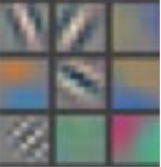

Example patterns that cause activations in the first layer of the network. These range from simple diagonal lines (top left) to green blobs (bottom middle).

The images above are from Matthew Zeiler and Rob Fergus' [**deep visualization toolbox**](https://www.youtube.com/watch?v=ghEmQSxT6tw), which lets us visualize what each layer in a CNN focuses on.

Each image in the above grid represents a pattern that causes the neurons in the first layer to activate - in other words, they are patterns that the first layer recognizes. The top left image shows a -45 degree line, while the middle top square shows a +45 degree line. These squares are shown below again for reference.



As visualized here, the first layer of the CNN can recognize -45 degree lines.

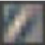

The first layer of the CNN is also able to recognize +45 degree lines, like the one above.

Let's now see some example images that cause such activations. The below grid of images all activated the -45 degree line. Notice how they are all selected despite the fact that they have different colors, gradients, and patterns.

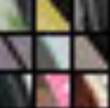

Example patches that activate the -45 degree line detector in the first layer.

So, the first layer of our CNN clearly picks out very simple shapes and patterns like lines and blobs.

### Layer 2

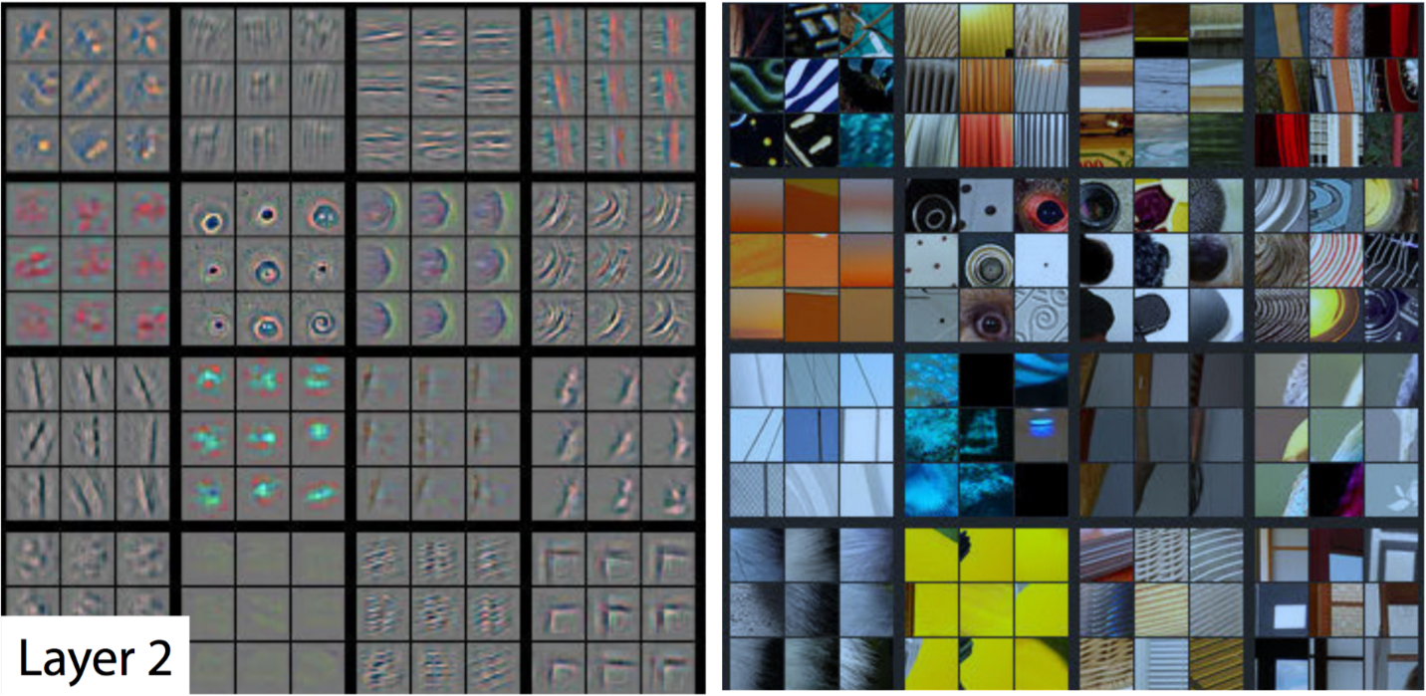

A visualization of the second layer in the CNN. Notice how we are picking up more complex ideas like circles and stripes. The gray grid on the left represents how this layer of the CNN activates (or "what it sees") based on the corresponding images from the grid on the right.

The second layer of the CNN captures complex ideas.

As you see in the image above, the second layer of the CNN recognizes circles (second row, second column), stripes (first row, second column), and rectangles (bottom right).

**The CNN learns to do this on its own.** There is no special instruction for the CNN to focus on more complex objects in deeper layers. That's just how it normally works out when you feed training data into a CNN.

### Layer 3

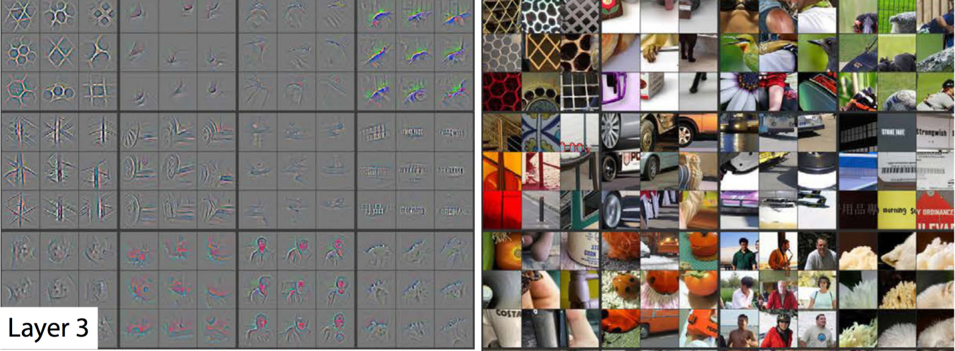

A visualization of the third layer in the CNN. The gray grid on the left represents how this layer of the CNN activates (or "what it sees") based on the corresponding images from the grid on the right.

The third layer picks out complex combinations of features from the second layer. These include things like grids, and honeycombs (top left), wheels (second row, second column), and even faces (third row, third column).

We'll skip layer 4, which continues this progression, and jump right to the fifth and final layer of this CNN.

### Layer 5

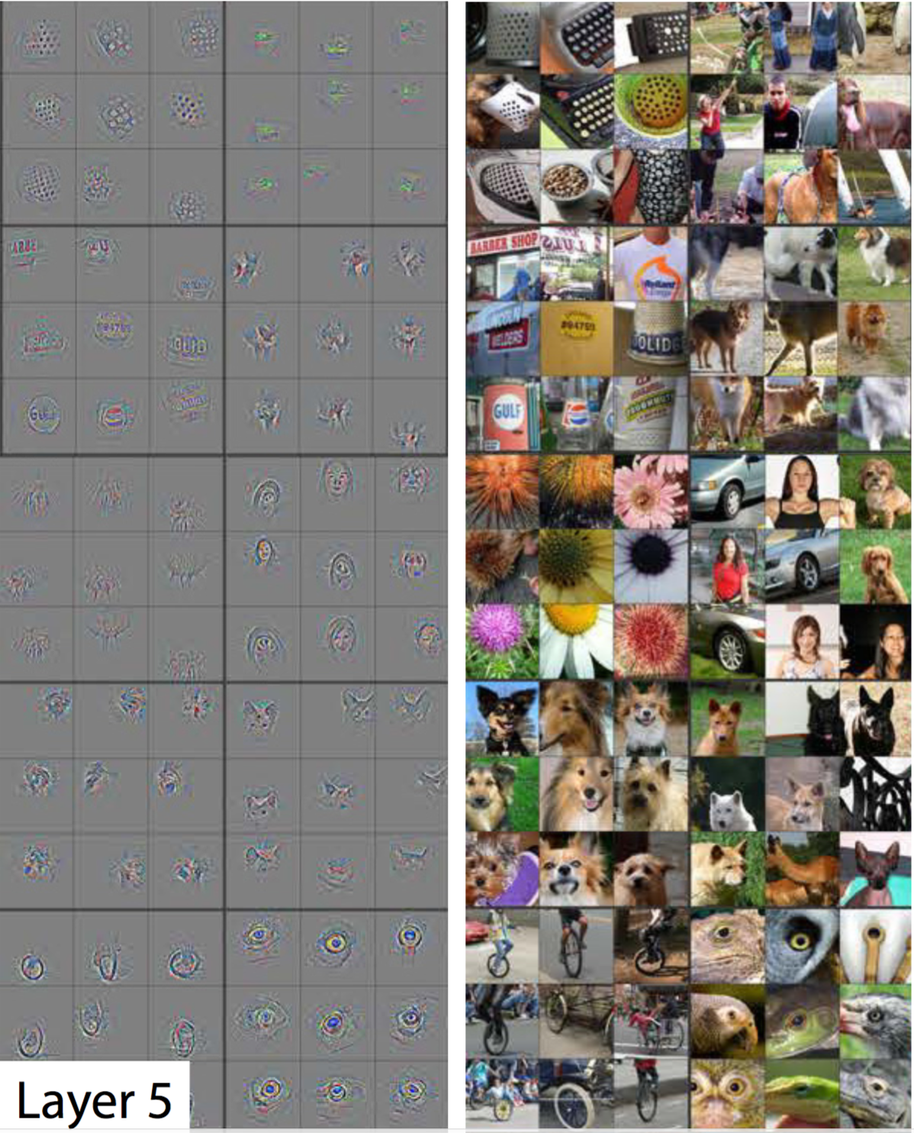

A visualization of the fifth and final layer of the CNN. The gray grid on the left represents how this layer of the CNN activates (or "what it sees") based on the corresponding images from the grid on the right.

The last layer picks out the highest order ideas that we care about for classification, like dog faces, bird faces, and bicycles.

## Summary Of CNNs

<https://www.youtube.com/watch?time_continue=0&v=Te9QCvhx6N8&feature=emb_logo>

# Lesson 2: Cloud Computing with AWS

## AWS Overview

SEND FEEDBACK



### What is EC2?

Amazon Web Services has a service called **Elastic Compute Cloud (EC2)**, which allows you to launch **virtual servers (or “instances”)**, including instances with attached GPUs. The specific type of GPU instance you should launch for this tutorial is called **“p2.xlarge”**.

### What is an Amazon Machine Image?

**Amazon Machine Image** or **AMI** is a template for an operating system and basic services (e.g., an application server and specific applications). By running an AMI instance, the AMI will be running "as a virtual server in the cloud" (as per [**AWS Documentation**](https://docs.aws.amazon.com/AWSEC2/latest/UserGuide/ec2-instances-and-amis.html).

We will use this [**AMI image**](https://aws.amazon.com/marketplace/pp/B077GF11NF) to define the operating system for your instance and to make use of its pre-installed software. In order to use this AMI, you must change your AWS region to one of the following (and you are encouraged to select the region in the list that is closest to you):

* EU (Ireland)
* Asia Pacific (Seoul)
* Asia Pacific (Tokyo)
* Asia Pacific (Sydney)
* US East (N. Virginia)
* US East (Ohio)
* US West (Oregon)

If you are unsure, please check the [**AWS documentation**](https://docs.aws.amazon.com/AWSEC2/latest/UserGuide/using-regions-availability-zones.html) to confirm which region may be closest to you.  
After changing your AWS region, view your **EC2 Service Limit report** at [**this link**](https://console.aws.amazon.com/ec2/v2/home?#Limits), and find your "Current Limit" for the p2.xlarge instance type.

### What is a P2 instance?

P2 are powerful and scalable parallel processing GPU instances. You can read more about these on [**AWS Documentation**](https://aws.amazon.com/ec2/instance-types/p2/).

### DO NOT FORGET TO SHUT DOWN YOUR EC2 INSTANCE or YOU WILL RUN OUT OF YOUR FREE PROMO CREDITS.

Your credits will be used for any **inactive running instances**. If you are in the middle of the project and need to step away, **PLEASE SHUT DOWN YOUR EC2 INSTANCE**. You can re-instantiate later. We have provided adequate credits to allow you to complete your projects.

## Get Access to GPU Instances

SEND FEEDBACK

Amazon Web Services (AWS) is an Infrastructure as a Service (IaaS) and Platform as a Service (PaaS) provider. At this point, we may think of a "cloud" as a geographically distributed set of data centers that host different Virtual Machines (VMs) from different users. AWS has divided the entire world into several geographical regions. Each region has many availability zones, which in turn, comprises few data centers. Each data center has hundreds of servers, each of which hosts thousands of VMs dynamically.

### A. What is EC2?

AWS Elastic Compute Cloud (EC2) is a hosted service that allows you to launch **Virtual Machines (or an “instances”)**, including instances with attached GPUs. You can get started by logging into the [**AWS Console**](https://aws.amazon.com/console/) and search for the "EC2" service, as shown below.

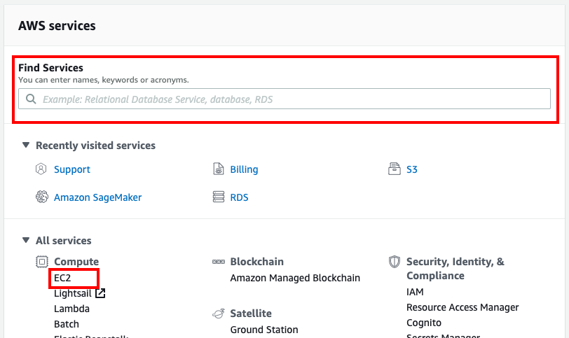

AWS Console - Select an AWS Service

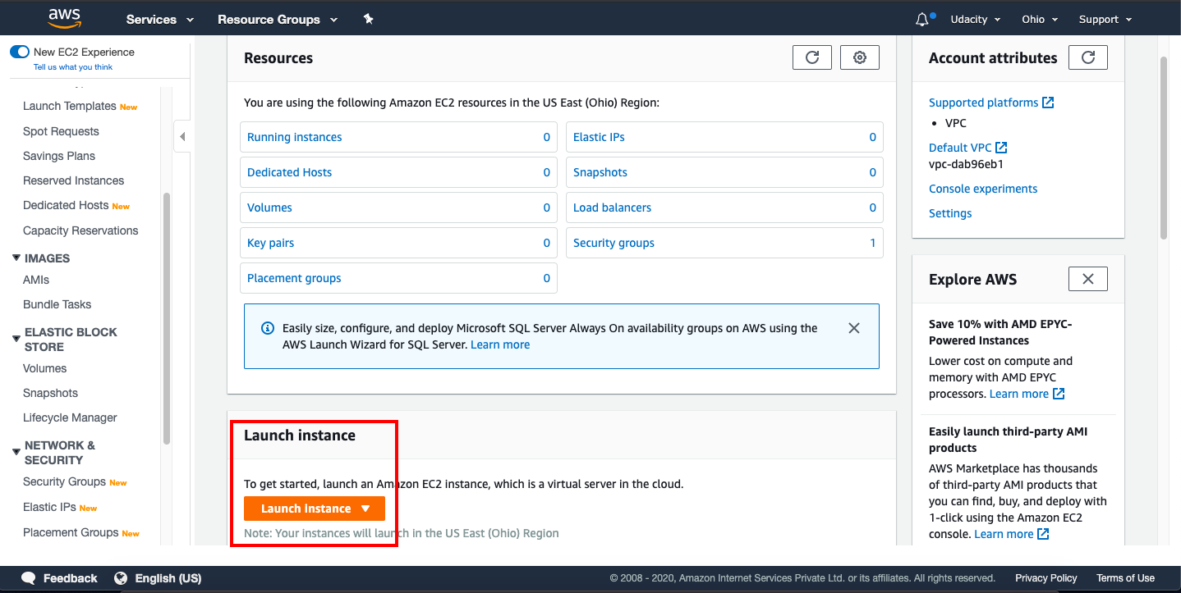

AWS Console - EC2 Dashboard

#### A.1. Launch an EC2 Instance

You can launch an instance in 7 simple steps, as follows:

1. Choose an Amazon Machine Image (AMI) - An AMI is a template that contains the software configuration (operating system, application server, and applications) required to launch your instance.
2. Choose an Instance Type - Instance Type offers varying combinations of CPUs, memory (GB), storage (GB), types of network performance, and availability of IPv6 support. AWS offers a variety of Instance Types, broadly categorized in 5 categories. You can choose an Instance Type that fits our use case. The specific type of GPU instance you should launch for this tutorial is called **“p2.xlarge”**.
3. Configure Instance Details - Provide the instance count and configuration details, such as, network, subnet, behavior, monitoring, etc.
4. Add Storage - You can choose to attach either SSD or Standard Magnetic drive to your instance.
5. Add Tags - A tag serves as a label that you can attach to multiple AWS resources, such as volumes, instances or both.
6. Configure Security Group - Attach a set of firewall rules to your instance(s) that controls the incoming traffic to your instance(s).
7. Review - Review your instance launch details before the launch.

#### A.2. What is an Amazon Machine Image?

**Amazon Machine Image** or **AMI** is a template for an operating system and basic services (e.g., an application server and specific applications). By running an AMI instance, the AMI will be running "as a virtual server in the cloud" (as per [**AWS Documentation**](https://docs.aws.amazon.com/AWSEC2/latest/UserGuide/ec2-instances-and-amis.html).

We will use this [**Deep Learning AMI (Amazon Linux)**](https://aws.amazon.com/marketplace/pp/B077GF11NF) to define the operating system for your instance and to make use of its pre-installed software. In order to use this AMI, you must change your AWS region to one of the following (and you are encouraged to select the region in the list that is closest to you):

* EU (Ireland)
* Asia Pacific (Seoul)
* Asia Pacific (Tokyo)
* Asia Pacific (Sydney)
* US East (N. Virginia)
* US East (Ohio)
* US West (Oregon)

If you are unsure, please check the [**AWS documentation**](https://docs.aws.amazon.com/AWSEC2/latest/UserGuide/using-regions-availability-zones.html) to confirm which region may be closest to you.  
After changing your AWS region, view your **EC2 Service Limit report** at [**this link**](https://console.aws.amazon.com/ec2/v2/home?#Limits), and find your "Current Limit" for the p2.xlarge instance type.

#### A.3. Instance Type - What is a P2 instance?

P2 are powerful and scalable parallel processing GPU instances. You can read more about these on [**AWS Documentation**](https://aws.amazon.com/ec2/instance-types/p2/).

### B. Shut Down EC2 Instances, if not in use

#### Note: We recommend you shut down every resource (e.g., EC2 instances, or any other hosted service) on the AWS cloud immediately after the usage, otherwise you will run out of your free promo credits.

Even if you are in the middle of the project and need to step away, **PLEASE SHUT DOWN YOUR EC2 INSTANCE**. You can re-instantiate later. We have provided adequate credits to allow you to complete your projects.

### C. AWS Service Utilization Limits

You need to understand the way AWS imposes **utilization quotas** (limits) on almost all of its services.

* AWS provides default quotas, formerly referred to as limits, **for each AWS service.**
* Importantly, **each quota is region-specific.**
* There are three ways to check your quotas, as mentioned [**here**](https://docs.aws.amazon.com/general/latest/gr/aws_service_limits.html), i). Service Endpoints and Quotas, ii). Service Quotas console, and iii). AWS CLI commands.
  + We recommend you to check the quotas for AWS EC2 at [**Service Endpoints and Quotas**](https://docs.aws.amazon.com/general/latest/gr/aws-service-information.html) page.
  + Alternatively, for EC2 service, you can visit [**Amazon EC2 Service Limits**](https://docs.aws.amazon.com/AWSEC2/latest/UserGuide/ec2-resource-limits.html) that describes how to view the current quota (limit) or request an increase in quota.

#### C.1. Increase EC2 Instance Limits

##### C.1.1. View Your Current Limit

After changing your AWS region, view your [**EC2 Service Limit report at this link**](https://console.aws.amazon.com/ec2/v2/home?#Limits), and find your "Current Limit" for the p2.xlarge instance type. By default, **AWS sets a limit of 0 on the number of p2.xlarge instances a user can run**, which effectively prevents you from launching this instance.

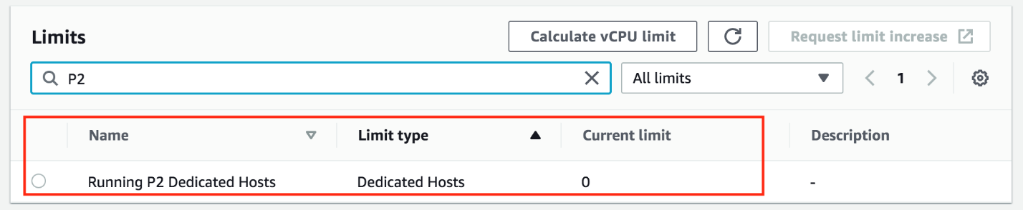

##### C.1.2. Submit a Limit Increase Request

If your limit of p2.xlarge instances is 0, you'll need to increase the limit before you can launch an instance.

1. From the EC2 Service Limits page, CLICK TO EDIT **Calculate vCPU limit** on top.

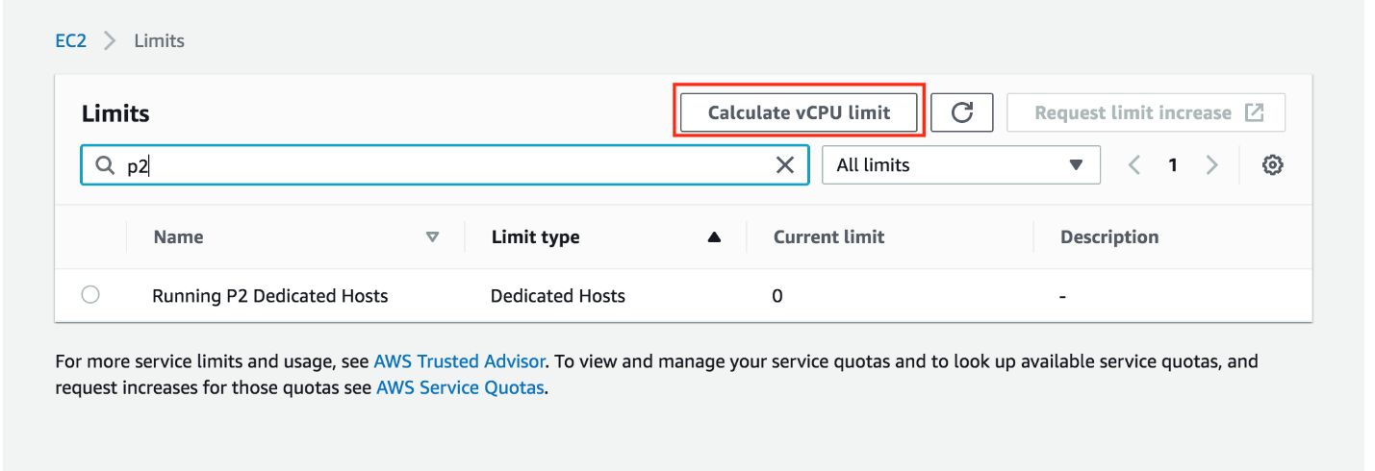

1. The following screen pops up. In the **Instance type** search for p2.xlarge and the **Instance count** to 1, verify the **New limit** is showing **4 vCPUs** and then click on **Request limit increase** ***Note:*** You won't be charged for requesting a limit increase. AWS will only charge you once you have launched the instance.

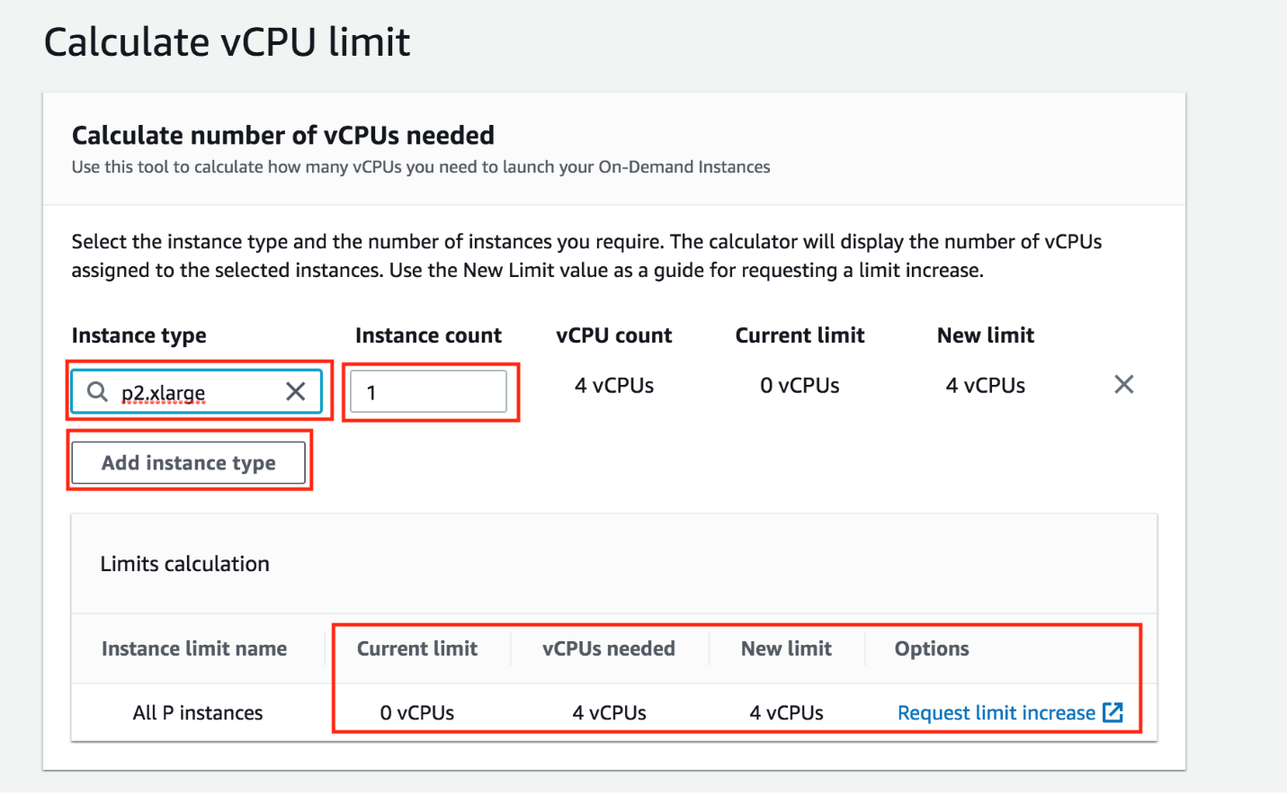

1. This will open the following screen. Click on the **Service limit increase** if it is not already selected.

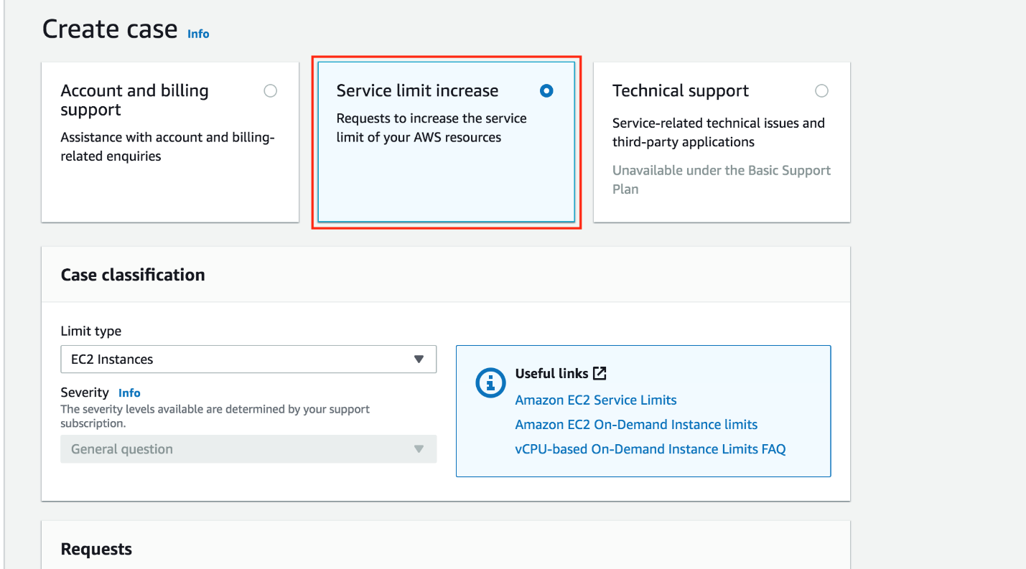

1. In **Requests** section pick your "Primary Instance type" as "All P instances" and "1" for "New limit value" ***Note:*** If you have never launched an instance of any type on AWS, you might receive an email from AWS Support asking you to initialize your account by creating an instance before they approve the limit increase.

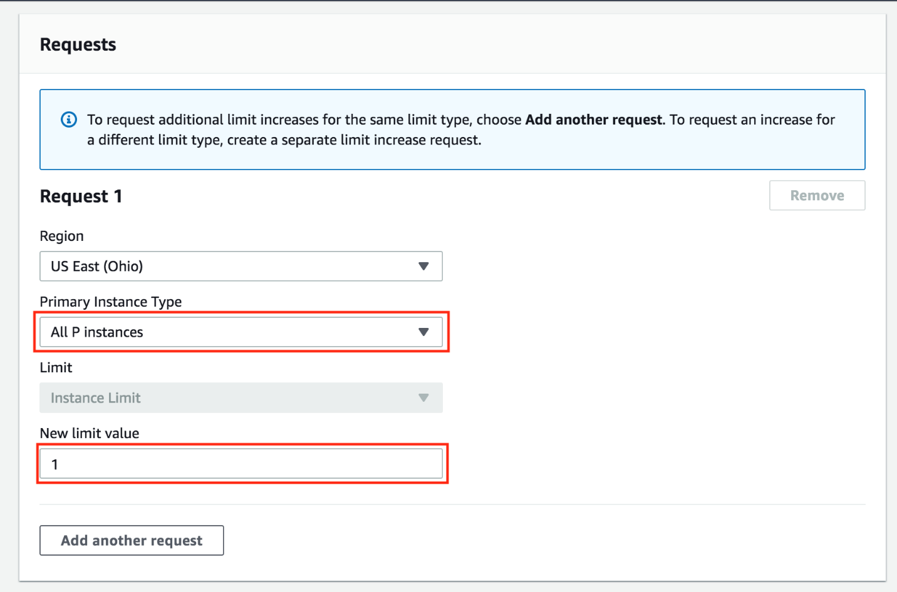

##### C.1.3. Wait for the Approval

You must wait for AWS to approve your Limit Increase Request. AWS typically approves these requests within 48 hours.

###### **IMPORTANT NOTICE: This is the current AWS UI as of April 6th, 2020. The AWS UI is subject to change on a regular basis. We advise students to refer to AWS documentation for the above process.**

## More Resources

### Cloud Providers, AWS

If you're enrolled in the complete program, you can use your AWS Promotional Credits to get started with AWS Machine Learning services such as Amazon SageMaker. Amazon SageMaker is a fully-managed machine learning platform that enables developers and data scientists to quickly and easily build, train, and deploy machine learning models at any scale. It removes all the barriers that typically slow down developers who want to use machine learning, so it's a perfect starting point on your machine learning journey.

[**Click here**](https://aws.amazon.com/machine-learning/aws-educate-and-udacity/) to learn more!



The cloud can connect data storage, analysis, and trained deep learning models.

#### Deployment via the Cloud

Using a cloud provider like AWS to spin up a GPU instance is really useful for training your own neural networks on the latest GPU hardware. There is one other benefit to using a cloud provider and that's **deployment**. Often, you'll want to deploy your pre-trained models so that they can respond to user data on a website! For example, [**this demo**](https://magenta.tensorflow.org/assets/sketch_rnn_demo/index.html) that uses a trained RNN to generate new sketches given user input.

You'll learn all about deployment later in this program, so we'll revisit the necessary instance-creation information, when we get there. The goal of this short, text lesson is really about getting you acquainted with GPU instances (should you want to use them), and introducing you to cloud providers like AWS.

## Launch an Instance

SEND FEEDBACK

### Launch an Instance

Once AWS approves your GPU Limit Increase Request, you can start the process of launching your instance.

Visit the [**EC2 Management Console**](https://console.aws.amazon.com/ec2/v2/home), and click on the “Launch Instance” button.

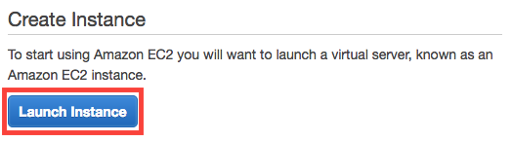

Next, you must choose an AMI (Amazon Machine Image) which defines the operating system for your instance, as well as any configurations and pre-installed software.

Click on **AWS Marketplace**, and search for **Deep Learning AMI with Source Code (CUDA 8, Ubuntu)**. Once you find the appropriate AMI, click on the "Select" button.

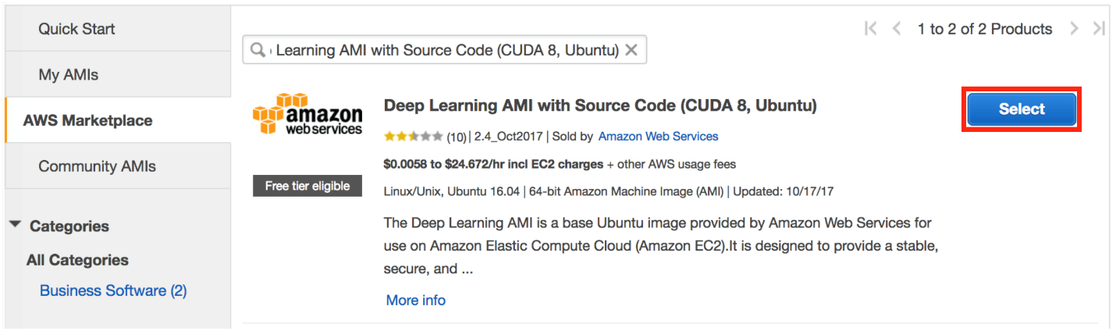

This [**Amazon Machine Image (AMI)**](http://docs.aws.amazon.com/AWSEC2/latest/UserGuide/AMIs.html) contains all the environment files and drivers for you to train on a GPU. It has **[cuDNN](https://developer.nvidia.com/cudnn" \t "_blank)**, and many the other packages required for this course. Any additional packages required for specific projects will be detailed in the appropriate project instructions.

### Select the Instance Type

You must next choose an instance type, which is the hardware on which the AMI will run.

Filter the instance list to only show “GPU compute”:

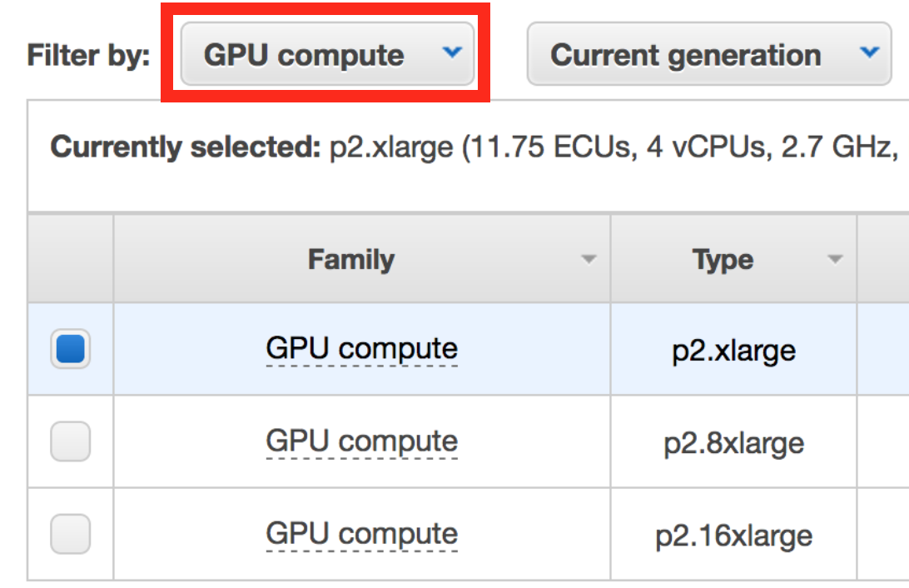

Select the p2.xlarge instance type:

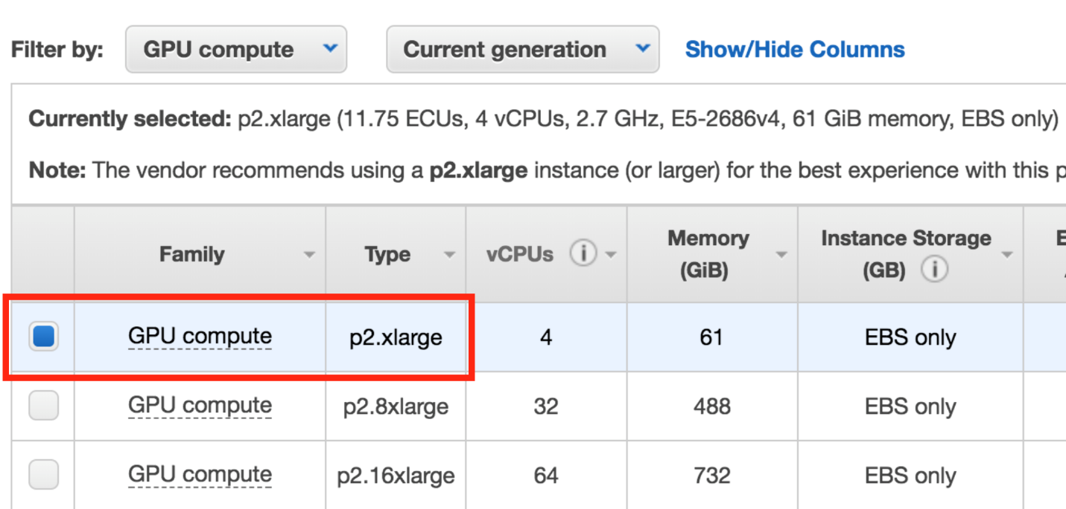

Finally, click on the "Review and Launch" button:



### Configure the Security Group

Running and accessing a Jupyter notebook from AWS requires special configurations.

By default, AWS restricts access to most ports on an EC2 instance. In order to access the Jupyter notebook, you must configure the AWS Security Group to allow access to port 8888.

Click on "Edit security groups".



On the "Configure Security Group" page:

1. Select "Create a **new** security group"
2. Set the "Security group name" (i.e. "Jupyter")
3. Click "Add Rule"
4. Set a "Custom TCP Rule"
   1. Set the "Port Range" to "8888"
   2. Select "Anywhere" as the "Source"
5. Click "Review and Launch" (again)

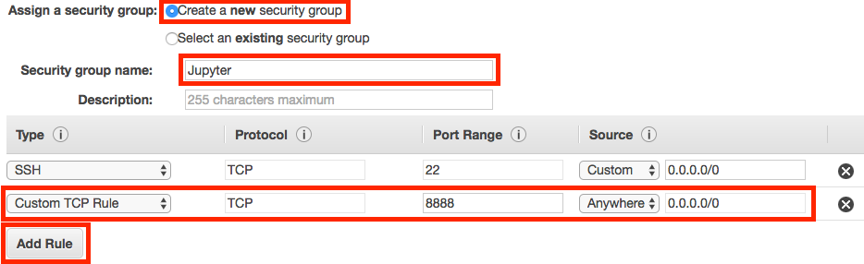

### Launch the Instance

Click on the “Launch” button to launch your GPU instance.



### Create an Authentication Key Pair

AWS will ask if you’d like to specify an authentication key pair. You'll need to do so in order to access your instance, so you select “Create a new key pair” and click the "Download Key Pair" button. This will download a .pem file, which you'll need to be able to access your instance.

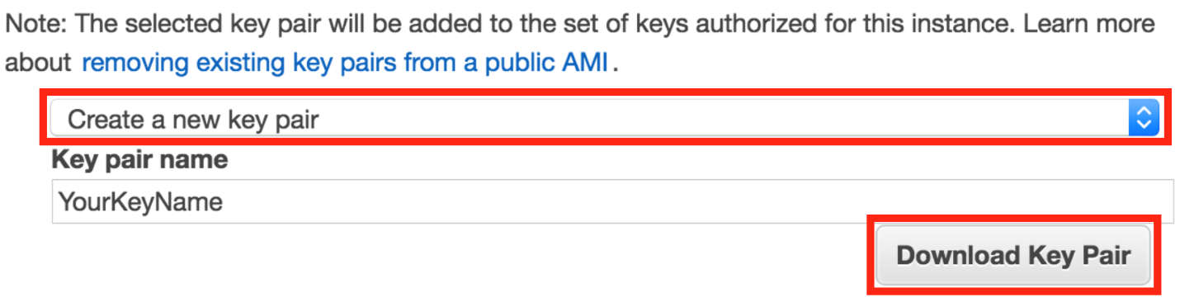

Move the .pem file to a secure and easily remembered location on your computer; you'll need to access your instance through the location you select.

After the .pem file has been downloaded, click the “Launch Instances” button.

Click the “View Instances” button to go to the EC2 Management Console and watch your instance boot.

### Be Careful!

From this point on, AWS will charge you for running this EC2 instance. You can find the details on the [**EC2 On-Demand Pricing page**](https://aws.amazon.com/ec2/pricing/on-demand/).

Most importantly, remember to “stop” (i.e. shutdown) your instances when you are not using them. Otherwise, your instances might run for a day, week, month, or longer without you remembering, and you’ll wind up with a large bill!

AWS charges primarily for running instances, so most of the charges will cease once you stop the instance. However, there are smaller storage charges that continue to accrue until you “terminate” (i.e. delete) the instance.

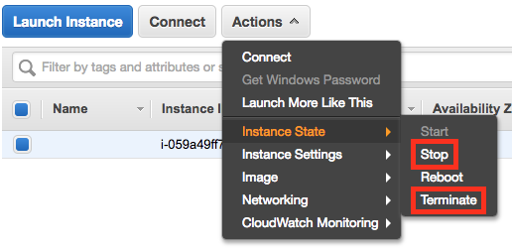

There is no way to limit AWS to only a certain budget and have it auto-shutdown when it hits that threshold. However, you can set [**AWS Billing Alarms**](http://docs.aws.amazon.com/awsaccountbilling/latest/aboutv2/free-tier-alarms.html).

### Login to the Instance

After launch, your instance may take a few minutes to initialize.

Once you see “2/2 checks passed” on the EC2 Management Console, your instance is ready for you to log in.

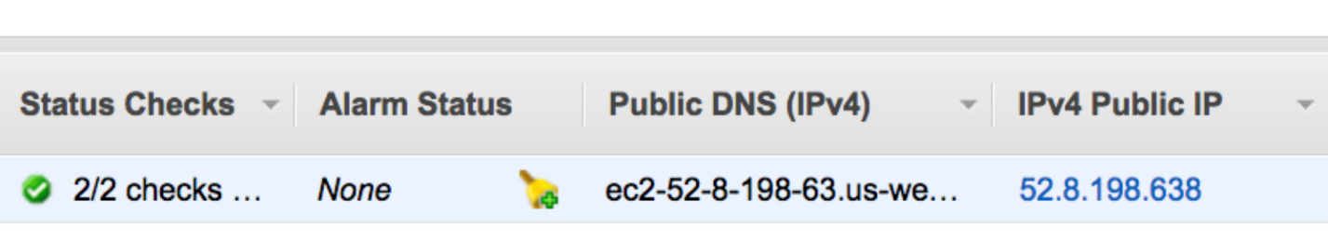

Instance Status Check and Public IP

Note the "IPv4 Public IP" address (in the format of “X.X.X.X”) on the EC2 Dashboard.

From a terminal, navigate to the location where you stored your .pem file. (For example, if you put your .pem file on your Desktop, cd ~/Desktop/ will move you to the correct directory.)

Type ssh -i YourKeyName.pem ubuntu@X.X.X.X, where:

* X.X.X.X is the IPv4 Public IP found in AWS, and
* YourKeyName.pem is the name of your .pem file.

Note that if you've used a different AMI or specified a username, ubuntu will be replaced with the username, such as ec2-user for some Amazon AMI's. You would then instead enter ssh -i YourKeyName.pem ec2-user@X.X.X.X

### Configure Jupyter notebook settings

In your instance, in order to create a config file for your Jupyter notebook settings, type: jupyter notebook --generate-config.

Then, to change the IP address config setting for notebooks (this is just a fancy one-line command to perform an exact string match replacement; you could do the same thing manually using vi/vim/nano/etc.), type: sed -ie "s/#c.NotebookApp.ip = 'localhost'/#c.NotebookApp.ip = '\*'/g" ~/.jupyter/jupyter\_notebook\_config.py

### Test the Instance

Make sure everything is working properly by verifying that the instance can run a notebook.

##### On the EC2 instance

* Clone a GitHub repository
  + git clone https://github.com/udacity/deep-learning-v2-pytorch.git
* Enter the repo directory, and the CNN subdirectory
  + cd deep-learning-pytorch
  + cd cnn-content
* Install the requirements
  + sudo python3 -m pip install -r requirements.txt
* Start Jupyter notebook
  + jupyter notebook --ip=0.0.0.0 --no-browser

##### From your local machine

* You will need the token generated by your jupyter notebook to access it. On your instance terminal, there will be the following line: Copy/paste this URL into your browser when you connect for the first time, to login with a token:. Copy everything starting with the :8888/?token=.
* Access the Jupyter notebook index from your web browser by visiting: X.X.X.X:8888/?token=... (where X.X.X.X is the IP address of your EC2 instance and everything starting with :8888/?token= is what you just copied).
* Click on a folder, like "mnist", to enter it and select a notebook, such as the "mnist\_mlp.ipynb" notebook.
* Run each cell in the notebook.

For some notebooks, you should see a marked decrease in training time when compared to running the same cells using a typical CPU!

**NOTE:** Windows users may prefer connecting via the GUI utility PuTTY, by following [**these instructions**](https://docs.aws.amazon.com/AWSEC2/latest/UserGuide/putty.html?icmpid=docs_ec2_console).

##### Important: Cost

**From this point on, AWS will charge you for a running an EC2 instance.**You can find the details on the [**EC2 On-Demand Pricing page**](https://aws.amazon.com/ec2/pricing/on-demand/).

Most importantly, remember to stop (i.e. shutdown) your instances when you are not using them. Otherwise, your instances might run for a day or a week or a month without you remembering, and you’ll wind up with a large bill!

AWS charges primarily for running instances, so most of the charges will cease once you stop the instance. However, there are smaller storage charges that continue to accrue until you “terminate” (i.e. delete) the instance.

# Lesson 3: Transfer Learning

## Transfer Learning

<https://www.youtube.com/watch?v=yfPEROi3SPU&feature=emb_logo>

## Useful Layers

<https://www.youtube.com/watch?v=kn4BN7z3UGQ&feature=emb_logo>

## Fine-Tuning with Transfer Learning

<https://www.youtube.com/watch?v=XOyb315xYbw&feature=emb_logo>

Transfer learning involves taking a pre-trained neural network and adapting the neural network to a new, different data set.

Depending on both:

* The size of the new data set, and
* The similarity of the new data set to the original data set

The approach for using transfer learning will be different. There are four main cases:

1. New data set is small, new data is similar to original training data.
2. New data set is small, new data is different from original training data.
3. New data set is large, new data is similar to original training data.
4. New data set is large, new data is different from original training data.

A large data set might have one million images. A small data could have two-thousand images. The dividing line between a large data set and small data set is somewhat subjective. Overfitting is a concern when using transfer learning with a small data set.

Images of dogs and images of wolves would be considered similar; the images would share common characteristics. A data set of flower images would be different from a data set of dog images.

Each of the four transfer learning cases has its own approach. In the following sections, we will look at each case one by one.

The graph below displays what approach is recommended for each of the four main cases.

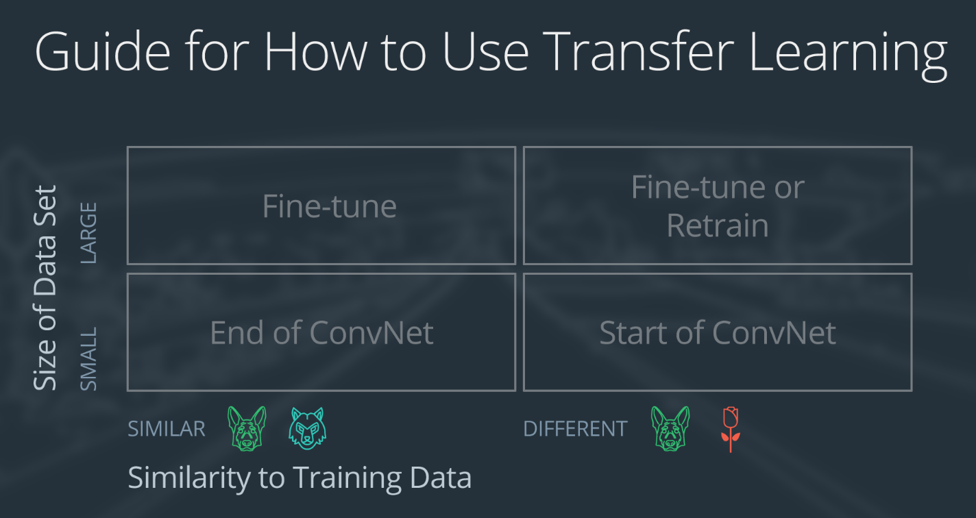

Four cases for using transfer learning.

### Demonstration Network

To explain how each situation works, we will start with a generic pre-trained convolutional neural network and explain how to adjust the network for each case. Our example network contains three convolutional layers and three fully connected layers:

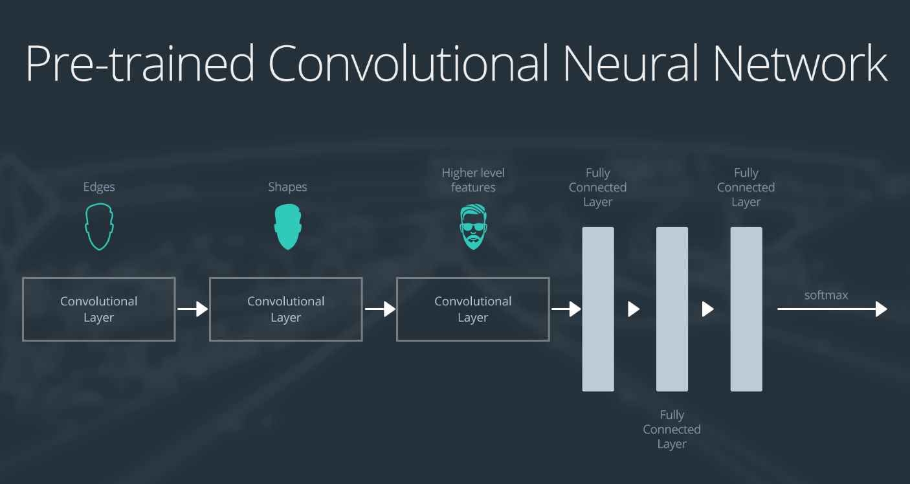

Overview of the layers of a pre-trained CNN.

Here is an generalized overview of what the convolutional neural network does:

* the first layer will detect edges in the image
* the second layer will detect shapes
* the third convolutional layer detects higher level features

Each transfer learning case will use the pre-trained convolutional neural network in a different way.

### Case 1: Small Data Set, Similar Data

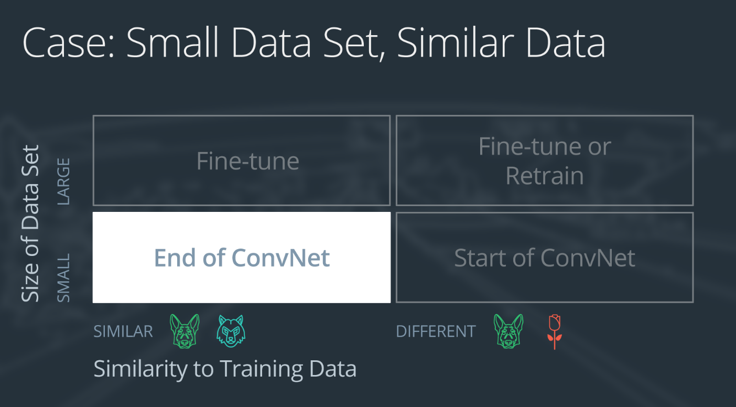

Case 1: small set, similar data

If the new data set is small and similar to the original training data:

* slice off the end of the neural network
* add a new fully connected layer that matches the number of classes in the new data set
* randomize the weights of the new fully connected layer; freeze all the weights from the pre-trained network
* train the network to update the weights of the new fully connected layer

To avoid overfitting on the small data set, the weights of the original network will be held constant rather than re-training the weights.

Since the data sets are similar, images from each data set will have similar higher level features. Therefore most or all of the pre-trained neural network layers already contain relevant information about the new data set and should be kept.

Here's how to visualize this approach:

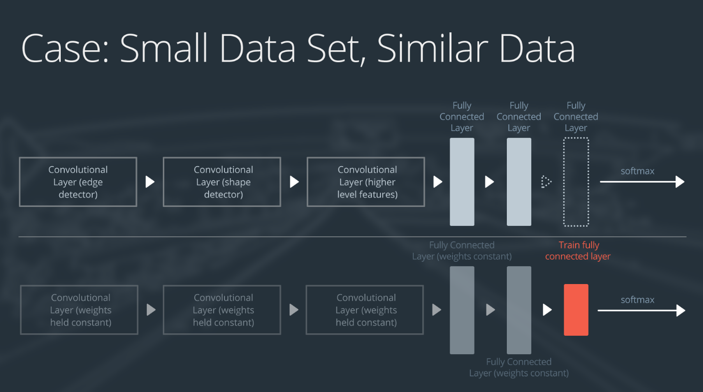

Adding and training a fully-connected layer at the end of the NN.

### Case 2: Small Data Set, Different Data

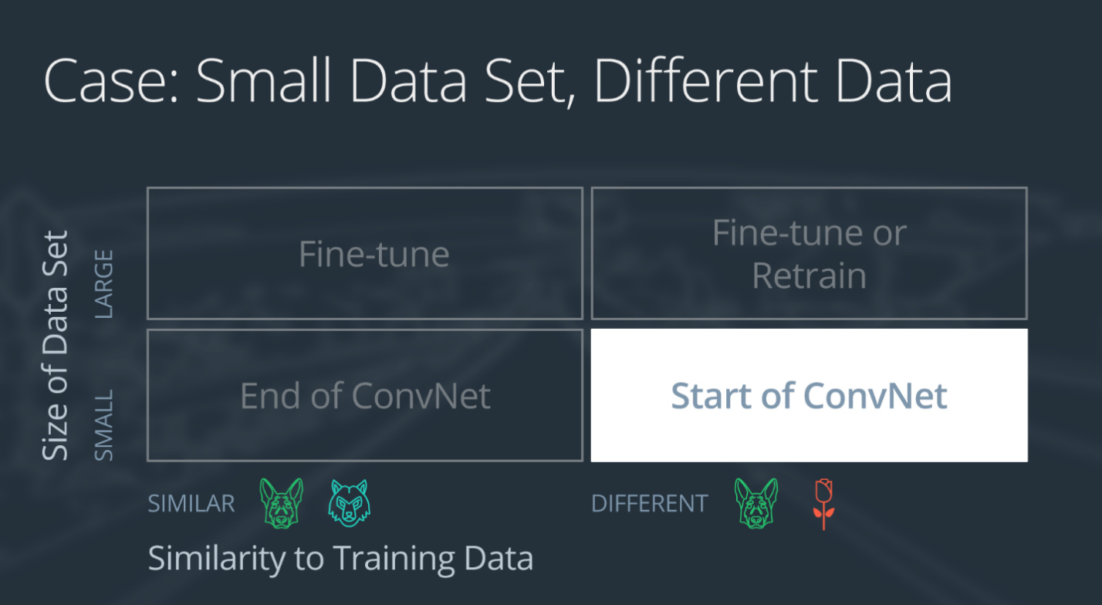

Case 2: small set, different data

If the new data set is small and different from the original training data:

* slice off all but some of the pre-trained layers near the beginning of the network
* add to the remaining pre-trained layers a new fully connected layer that matches the number of classes in the new data set
* randomize the weights of the new fully connected layer; freeze all the weights from the pre-trained network
* train the network to update the weights of the new fully connected layer

Because the data set is small, overfitting is still a concern. To combat overfitting, the weights of the original neural network will be held constant, like in the first case.

But the original training set and the new data set do not share higher level features. In this case, the new network will only use the layers containing lower level features.

Here is how to visualize this approach:

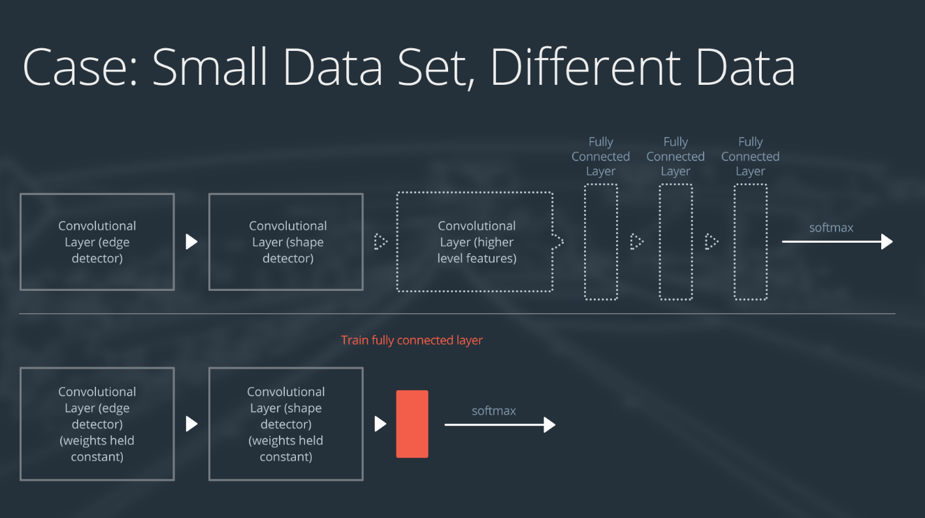

Remove all but the starting layers of the model, and add and train a linear layer at the end.

### Case 3: Large Data Set, Similar Data

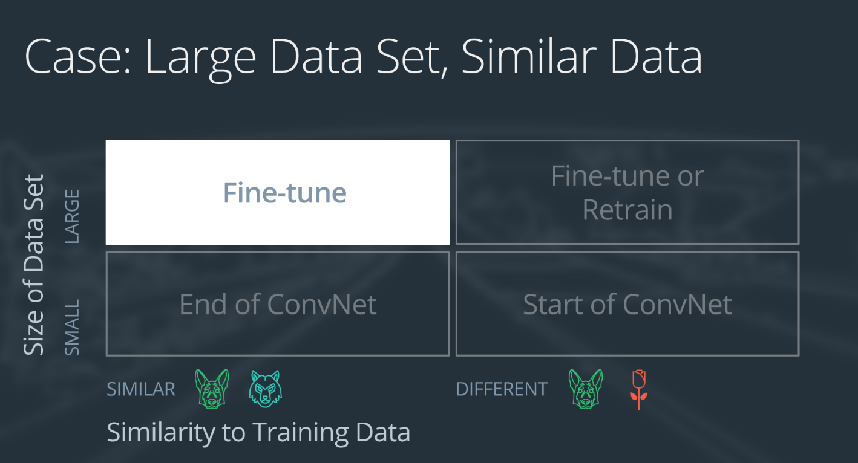

Case 3: large data, similar to ImageNet or pre-trained set.

If the new data set is large and similar to the original training data:

* remove the last fully connected layer and replace with a layer matching the number of classes in the new data set
* randomly initialize the weights in the new fully connected layer
* initialize the rest of the weights using the pre-trained weights
* re-train the entire neural network

Overfitting is not as much of a concern when training on a large data set; therefore, you can re-train all of the weights.

Because the original training set and the new data set share higher level features, the entire neural network is used as well.

Here is how to visualize this approach:

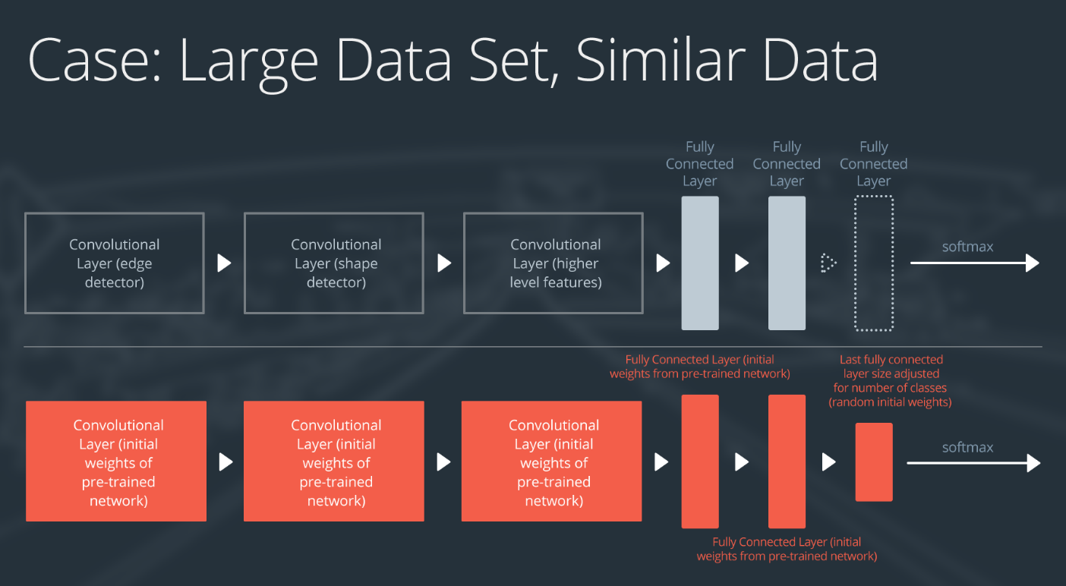

Utilizing pre-trained weights as a starting point!

### Case 4: Large Data Set, Different Data

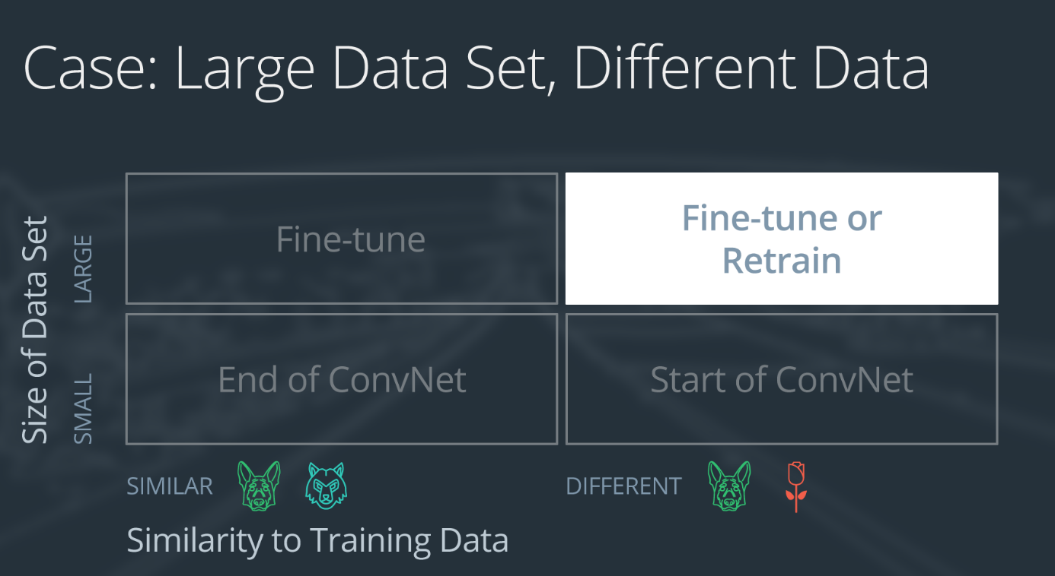

Case 4: large data, different than original set

If the new data set is large and different from the original training data:

* remove the last fully connected layer and replace with a layer matching the number of classes in the new data set
* retrain the network from scratch with randomly initialized weights
* alternatively, you could just use the same strategy as the "large and similar" data case

Even though the data set is different from the training data, initializing the weights from the pre-trained network might make training faster. So this case is exactly the same as the case with a large, similar data set.

If using the pre-trained network as a starting point does not produce a successful model, another option is to randomly initialize the convolutional neural network weights and train the network from scratch.

Here is how to visualize this approach:

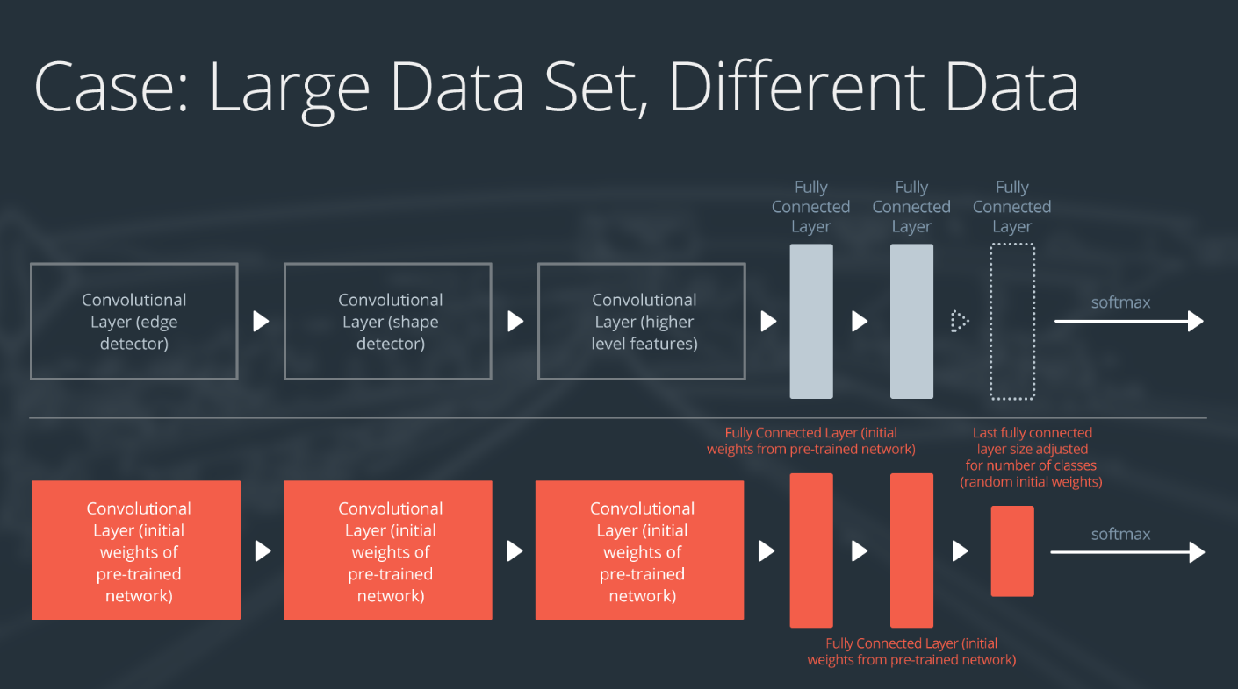

Fine-tune or retrain entire network.

### Optional Resources

* Check out this [**research paper**](https://arxiv.org/pdf/1411.1792.pdf) that systematically analyzes the transferability of features learned in pre-trained CNNs.
* Read the [**Nature publication**](http://www.nature.com/articles/nature21056.epdf?referrer_access_token=_snzJ5POVSgpHutcNN4lEtRgN0jAjWel9jnR3ZoTv0NXpMHRAJy8Qn10ys2O4tuP9jVts1q2g1KBbk3Pd3AelZ36FalmvJLxw1ypYW0UxU7iShiMp86DmQ5Sh3wOBhXDm9idRXzicpVoBBhnUsXHzVUdYCPiVV0Slqf-Q25Ntb1SX_HAv3aFVSRgPbogozIHYQE3zSkyIghcAppAjrIkw1HtSwMvZ1PXrt6fVYXt-dvwXKEtdCN8qEHg0vbfl4_m&tracking_referrer=edition.cnn.com) detailing Sebastian Thrun's cancer-detecting CNN!

## VGG Model & Classifier

<https://www.youtube.com/watch?time_continue=0&v=fOiQFXItYe4&feature=emb_logo>

## Notebook: Transfer Learning

Now, you're ready to use transfer learning on a new task!

**It's suggested that you open the notebook in a new, working tab and continue working on it as you go through the instructional videos in this tab.** This way you can toggle between learning new skills and coding/applying new skills.

To open this notebook, you have two options:

* Go to the next page in the classroom (recommended).
* Clone the repo from [**Github**](https://github.com/udacity/deep-learning-v2-pytorch) and open the notebook **Transfer\_Learning\_Exercise.ipynb** in the **transfer-learning** folder. You can either download the repository with git clone https://github.com/udacity/deep-learning-v2-pytorch.git, or download it as an archive file from [**this link**](https://github.com/udacity/deep-learning-v2-pytorch/archive/master.zip).

### Instructions

* Load in a pre-trained VGG Net
* Freeze the weights in selected layers and add a new, linear layer of your own design
* Train the modified model for a couple epochs and test its performance

This is a self-assessed lab. If you need any help or want to check your answers, feel free to check out the solutions notebook in the same folder, or by clicking [**here**](https://github.com/udacity/deep-learning-v2-pytorch/blob/master/transfer-learning/Transfer_Learning_Solution.ipynb).

### GPU Workspaces

The next workspace is **GPU-enabled**, which means you can select to train on a GPU instance. The recommendation is this:

* Load in data, test functions and models (checking parameters and doing a short training loop) while in CPU (non-enabled) mode
* When you're ready to extensively train and test your model, **enable** GPU to quickly train the model!

All models and data they see as input will have to be moved to the GPU device, so take note of the relevant movement code in the model creation and training process.

## Freezing Weights & Last Layer

<https://www.youtube.com/watch?v=ssNIX_2QfMQ&feature=emb_logo>

## Last Layer

<https://www.youtube.com/watch?v=4LniBMFI53g&feature=emb_logo>

# Lesson 4: Weight Initialization

## Weight Initialization

<https://www.youtube.com/watch?time_continue=0&v=Ehc60si91Wg&feature=emb_logo>

## Constant Weights

<https://www.youtube.com/watch?time_continue=0&v=zR4fECgeZ7Y&feature=emb_logo>

## Random Uniform

<https://www.youtube.com/watch?time_continue=1&v=FacdIomrLIw&feature=emb_logo>

## General Rule

<https://www.youtube.com/watch?v=YKe9iOUMmsI&feature=emb_logo>

## Normal Distribution

<https://www.youtube.com/watch?v=xm43q4qD2tI&feature=emb_logo>

## Notebook: Weight Initialization

Now, you're ready to try out a weight initialization method that you define.

To open this notebook, you have two options:

* Go to the next page in the classroom (recommended).
* Clone the repo from [**Github**](https://github.com/udacity/deep-learning-v2-pytorch) and open the notebook **weight\_initialization\_exercise.ipynb** in the \*weight-initialization folder. You can either download the repository with git clone https://github.com/udacity/deep-learning-v2-pytorch.git, or download it as an archive file from [**this link**](https://github.com/udacity/deep-learning-v2-pytorch/archive/master.zip).

### Instructions

* Load in the FashionMNIST data
* Define a function to initialize the weights of your model, taking values from a normal distribution
* See how a model without any explicit weight initialization performs

This is a self-assessed lab. If you need any help or want to check your answers, feel free to check out the solutions notebook in the same folder, or by clicking [**here**](https://github.com/udacity/deep-learning-v2-pytorch/blob/master/weight-initialization/weight_initialization_solution.ipynb).

## Solution and Default Initialization

<https://www.youtube.com/watch?v=xIn8XLbR1LM&feature=emb_logo>

## Additional Material

New techniques for dealing with weights are discovered every few years. We've provided the most popular papers in this field over the years.

* [**Understanding the difficulty of training deep feedforward neural networks**](http://jmlr.org/proceedings/papers/v9/glorot10a/glorot10a.pdf)
* [**Delving Deep into Rectifiers: Surpassing Human-Level Performance on ImageNet Classification**](https://arxiv.org/pdf/1502.01852v1.pdf)
* [**Batch Normalization: Accelerating Deep Network Training by Reducing Internal Covariate Shift**](https://arxiv.org/pdf/1502.03167v2.pdf)

# Lesson 5: Autoencoders

## Autoencoders

<https://www.youtube.com/watch?time_continue=0&v=a5zHMWOq0fc&feature=emb_logo>

## Simple Linear Autoencoder

<https://www.youtube.com/watch?v=KbmfyDNxL5U&feature=emb_logo>

## Notebook: Linear Autoencoder

**It's suggested that you open the notebook in a new, working tab and continue working on it as you go through the instructional videos in this tab.** This way you can toggle between learning new skills and coding/applying new skills.

To open this notebook, you have two options:

* Go to the next page in the classroom (recommended).
* Clone the repo from [**Github**](https://github.com/udacity/deep-learning-v2-pytorch) and open the notebook **Simple\_Autoencoder\_Exercise.ipynb** in the **autoencoder > linear-autoencoder** folder. You can either download the repository with git clone https://github.com/udacity/deep-learning-v2-pytorch.git, or download it as an archive file from [**this link**](https://github.com/udacity/deep-learning-v2-pytorch/archive/master.zip).

### Instructions

* Define and train a linear autoencoder

This is a self-assessed lab. If you need any help or want to check your answers, feel free to check out the solutions notebook in the same folder, or by clicking [**here**](https://github.com/udacity/deep-learning-v2-pytorch/blob/master/autoencoder/linear-autoencoder/Simple_Autoencoder_Solution.ipynb).

## Defining & Training an Autoencoder

<https://www.youtube.com/watch?time_continue=0&v=OWrlQUSGqyo&feature=emb_logo>

## A Simple Solution

<https://www.youtube.com/watch?v=Jh3mbomqpw8&feature=emb_logo>

## Learnable Upsampling

<https://www.youtube.com/watch?time_continue=0&v=KjztLwPksj8&feature=emb_logo>

## Transpose Convolutions

<https://www.youtube.com/watch?v=hnnLAC1Q0zg&feature=emb_logo>

## Convolutional Autoencoder

<https://www.youtube.com/watch?time_continue=1&v=QCA8QeZeDW8&feature=emb_logo>

## Notebook: Convolutional Autoencoder

**It's suggested that you open the notebook in a new, working tab and continue working on it as you go through the instructional videos in this tab.** This way you can toggle between learning new skills and coding/applying new skills.

To open this notebook, you have two options:

* Go to the next page in the classroom (recommended).
* Clone the repo from [**Github**](https://github.com/udacity/deep-learning-v2-pytorch) and open the notebook **Convolutional\_Autoencoder\_Exercise.ipynb** in the **autoencoder > convolutional-autoencoder** folder. You can either download the repository with git clone https://github.com/udacity/deep-learning-v2-pytorch.git, or download it as an archive file from [**this link**](https://github.com/udacity/deep-learning-v2-pytorch/archive/master.zip).

### Instructions

* Define and train a convolutional autoencoder

This is a self-assessed lab. If you need any help or want to check your answers, feel free to check out the solutions notebook in the same folder, or by clicking [**here**](https://github.com/udacity/deep-learning-v2-pytorch/blob/master/autoencoder/convolutional-autoencoder/Convolutional_Autoencoder_Solution.ipynb).

### Exercise: GPU Workspaces

**You do not need to enable GPU to complete this exercise.** This is left as an optional exercise; you will be responsible for moving your models and data to GPU, should you choose to enable it.

The next workspace is **GPU-enabled**, which means you can select to train on a GPU instance. The recommendation is this:

* Load in data, test functions and models (checking parameters and doing a short training loop) while in CPU (non-enabled) mode
* When you're ready to extensively train and test your model, **enable** GPU to quickly train the model!

All models and data they see as input will have to be moved to the GPU device, so take note of the relevant movement code in the model creation and training process.

## Convolutional Solution

<https://www.youtube.com/watch?v=2_Yw9LLomCo&feature=emb_logo>

## Upsampling and Denoising

<https://www.youtube.com/watch?time_continue=0&v=XX63da4EPN0&feature=emb_logo>

## Denoising

<https://www.youtube.com/watch?v=RIfEhKev24I&feature=emb_logo>

## Notebook: De-noising Autoencoder

Try defining and training an autoencoder for denoising images!

To open this notebook, you have two options:

* Go to the next page in the classroom (recommended).
* Clone the repo from [**Github**](https://github.com/udacity/deep-learning-v2-pytorch) and open the notebook **Denoising\_Autoencoder\_Exercise.ipynb** in the **autoencoder > denoising-autoencoder** folder. You can either download the repository with git clone https://github.com/udacity/deep-learning-v2-pytorch.git, or download it as an archive file from [**this link**](https://github.com/udacity/deep-learning-v2-pytorch/archive/master.zip).

### Instructions

* Define and train a convolutional autoencoder
* Add more/deeper layers to create a successful de-noiser

This is a self-assessed lab. If you need any help or want to check your answers, feel free to check out one kind of solution in the following notebook, or by clicking [**here**](https://github.com/udacity/deep-learning-v2-pytorch/blob/master/autoencoder/denoising-autoencoder/Denoising_Autoencoder_Solution.ipynb).

### Exercise: GPU Workspaces

**You do not need to enable GPU to complete this exercise.** This is left as an optional exercise; you will be responsible for moving your models and data to GPU, should you choose to enable it.

The next workspace is **GPU-enabled**, which means you can select to train on a GPU instance. The recommendation is this:

* Load in and test models while in CPU (non-enabled) mode
* When you're ready to extensively train and test your model, you'll have to add GPU functionality (in this case, the code is not provided for you)
* Once you've moved your model and data to GPU, you can **enable** GPU to quickly train the model!

All models and data they see as input will have to be moved to the GPU device, so take note of the relevant movement code in the model creation and training process.